**MySQL practice**

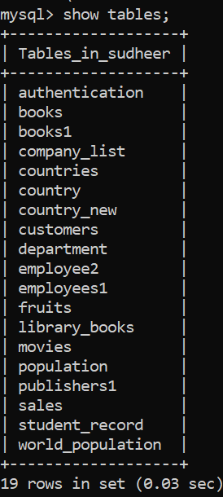

Select statement in MySQL is used to select data from Database(tables).

Syntax: select column1,column2 ------column n from table name.

Eg : 1) select Name, Gender from population …. ……… ……..[that we have created in CLI ] it shows only columns that we asked for in whole table.

mysql> select Name,Gender from Population;

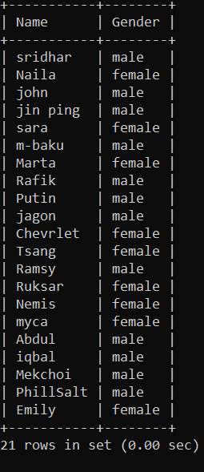

2) mysql> select Age,Qualification from Population;

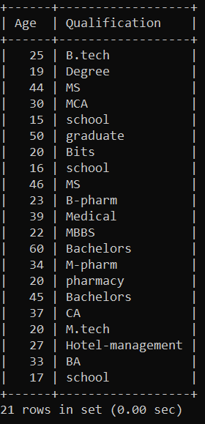

3) mysql> select Country_Name,Population from Population;

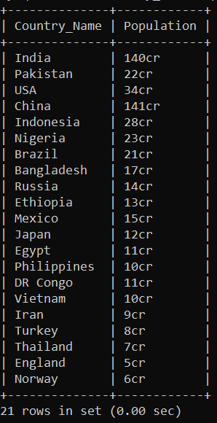

4) mysql> select Name,Occupation from Population;

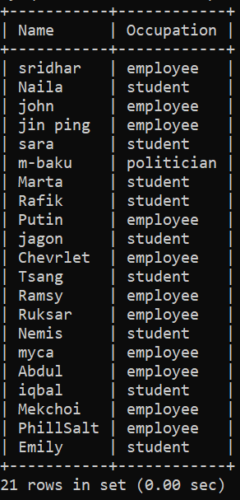

5) mysql> select Gender,Country_Name from Population;

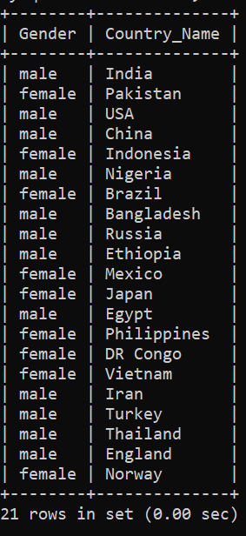

6) mysql> select state_number,capital from states;

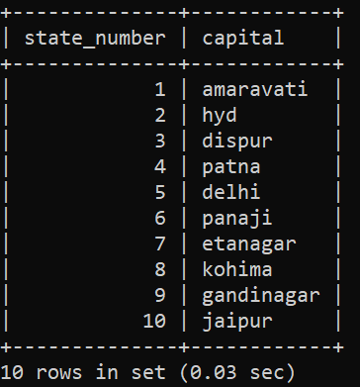

7) mysql> select prod_id,price from inventory;

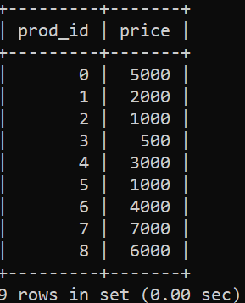

8) mysql> select course from student_record;

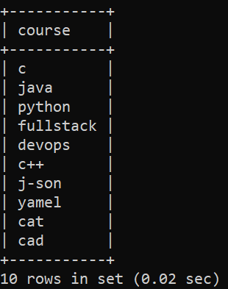

9) mysql> select username,password from Authentication;

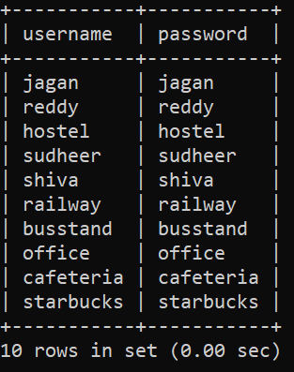

10) mysql> select user_id,email from Authentication;

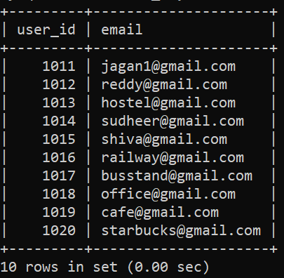

Distinct select:

1) mysql> select distinct Name,Country_Name from Population;

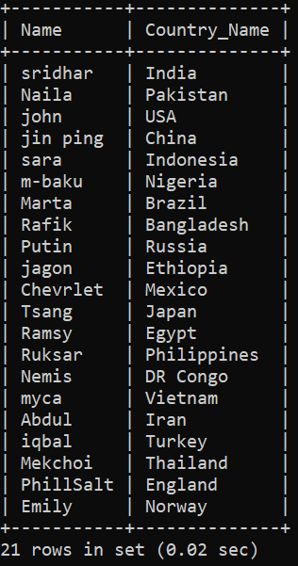

2) mysql> select distinct prod_id,product_name,price from inventory;

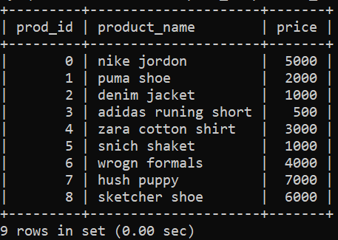

3) mysql> select distinct prod_id,price from inventory;

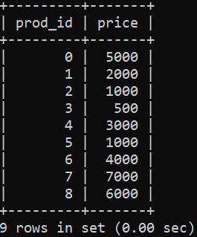

4) mysql> select distinct title,published_year from Library_books ;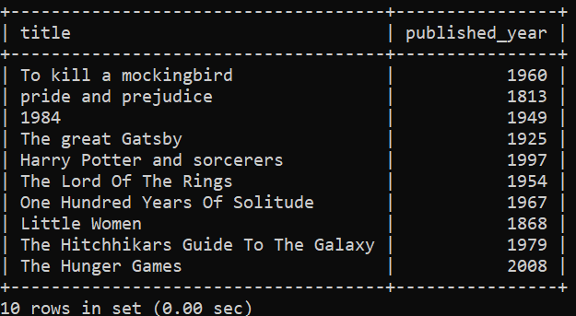

5) mysql> select distinct name,course from student_record;

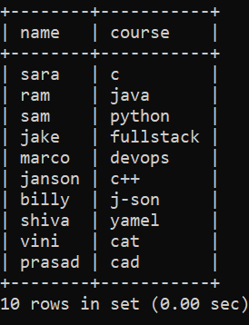

6) mysql> select distinct population from Population;

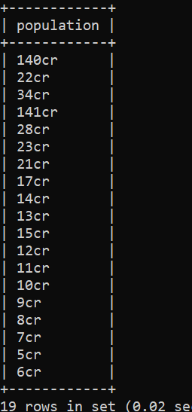 here out of 21 we got 19,bcs distinct selection won’t allows duplicate.

7) mysql> select distinct username,password from Authentication;

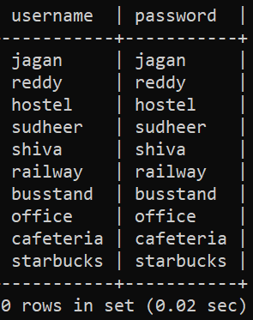

8) mysql> select distinct Occupation from Population;

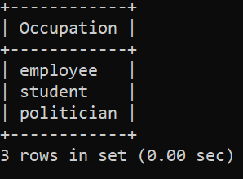

9) mysql> select distinct Gender from Population;

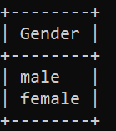

10) mysql> select distinct Age,Gender from Population;

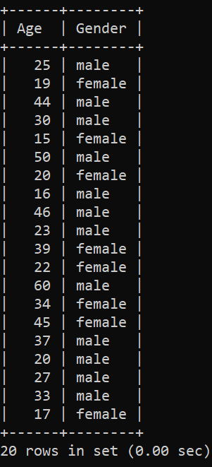

Where clause :

1. mysql> select Name,Age from Population where Gender='female';

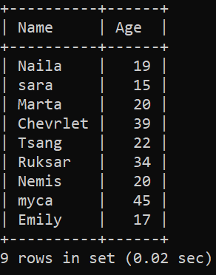

1. mysql> select Name,Occupation from Population where Age=20;

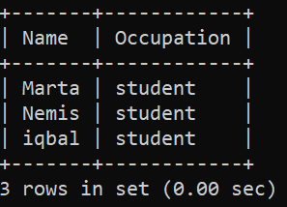

1. mysql> select Gender,Country_Name from Population where Qualification='school';

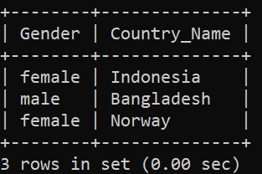

1. mysql> select Name,Population from Population where Occupation='employee';

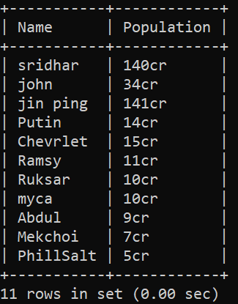

1. mysql> select Country_Name from Population where Gender='male';

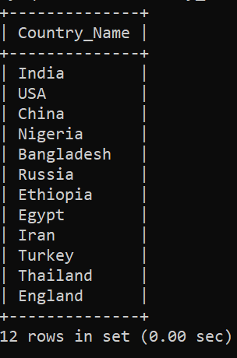

1. mysql> select * from Population where Age=22;

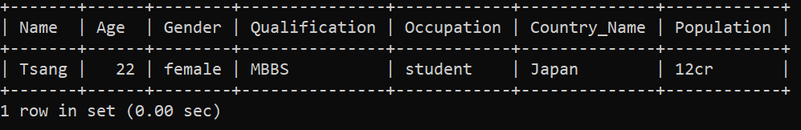

1. mysql> select * from Population where Population=140;

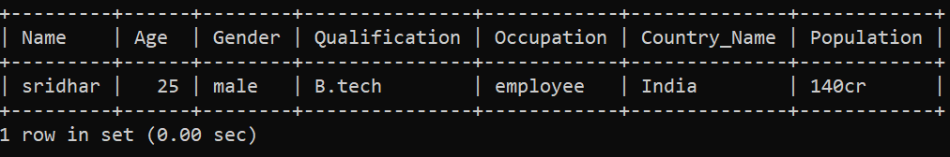

1. mysql> select * from Population where Occupation='student';

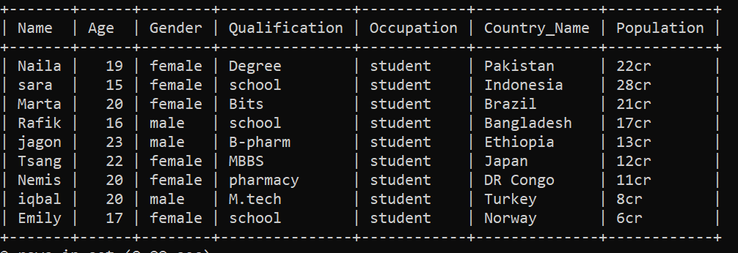

1. mysql> select Gender from Population where Age=50;

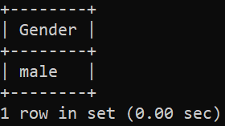

1. mysql> select Population,Age from Population where Age=25;

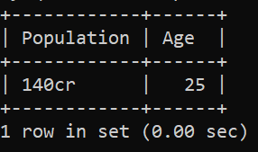

* we can use this clause for Arithmetic, between, like, In and Logical operators also.
* For grater than :

1. mysql> select * from Population where Age>22;

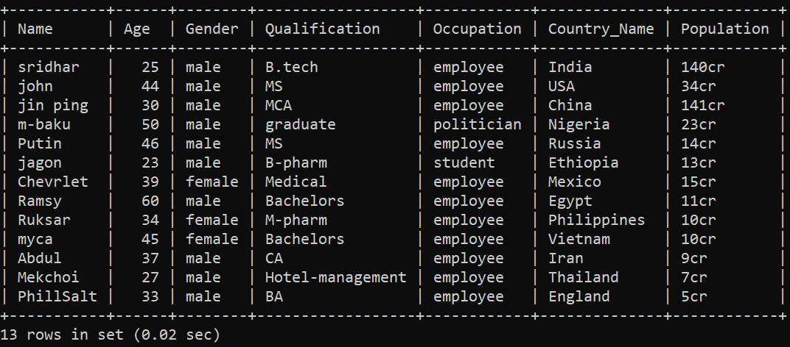

1. mysql> select Name,Population from Population where Age>22;

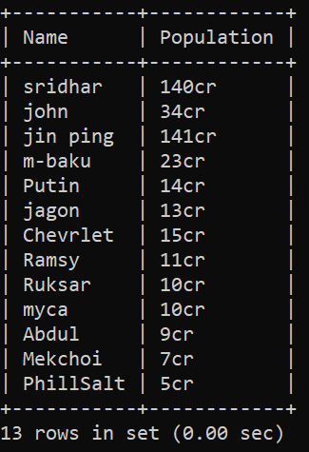

1. mysql> select Gender,Country_Name from Population where Age>40;

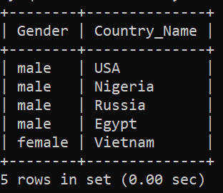

1. mysql> select Country_Name from Population where Qualification>'school';

Empty set (0.00 sec)

1. mysql> select Qualification,Occupation from Population where Age>50;

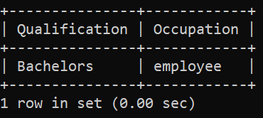

1. mysql> select Gender,Country_Name from Population where Age>33;

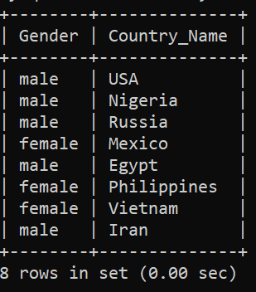

1. mysql> select Gender,Country_Name from Population where Age>15;

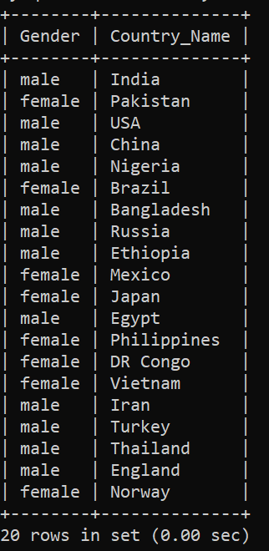

1. mysql> select Age from Population where Population>28;

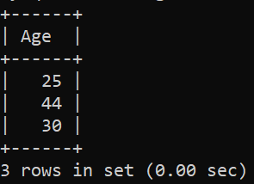

1. mysql> select Name,Qualification from Population where Population>28;

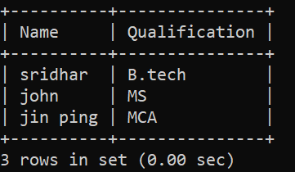

1. mysql> select Occupation from Population where Age>46;

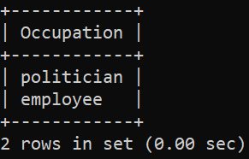

* for less than:

1. mysql> select * from Population where Age<22;

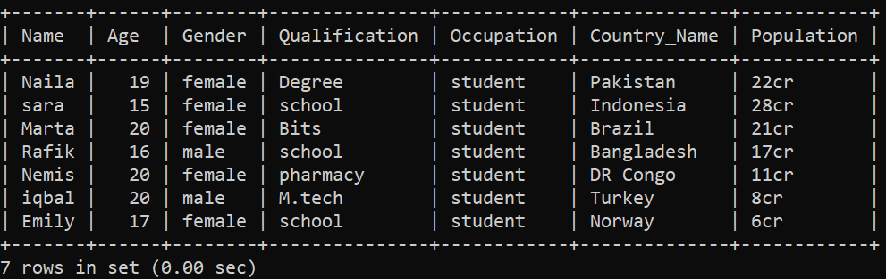

1. mysql> select Name,Population from Population where Age<22;

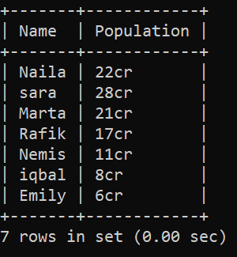

1. mysql> select Gender,Country_Name from Population where Age<40;

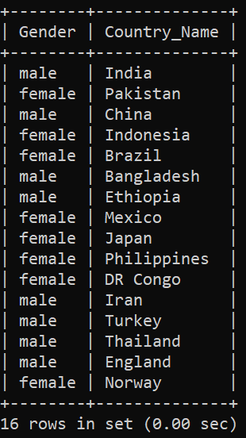

1. mysql> select Name,Population from Population where Age<18;

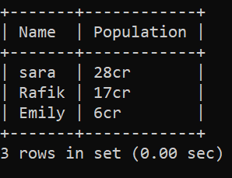

1. mysql> select Qualification,Occupation from Population where Age<50;

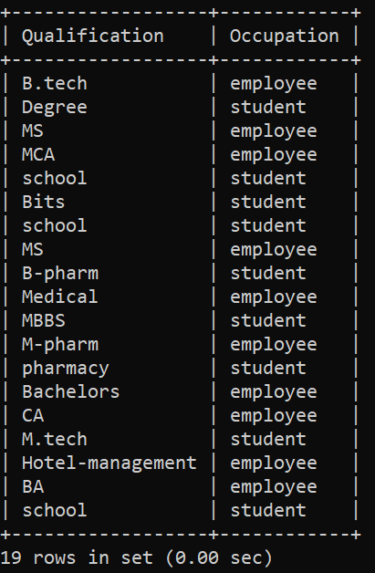

1. mysql> select Occupation from Population where Age<46;

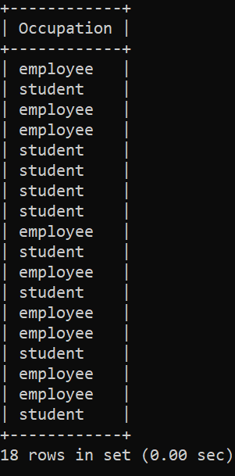

1. mysql> select Name,Qualification from Population where Population<28;

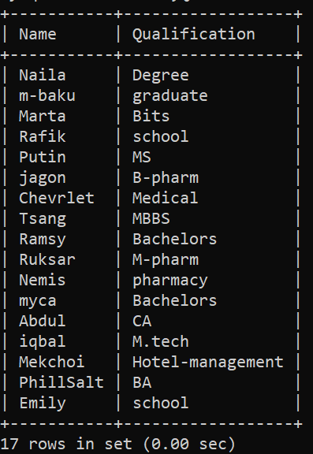

1. mysql> select Age from Population where Population<28;

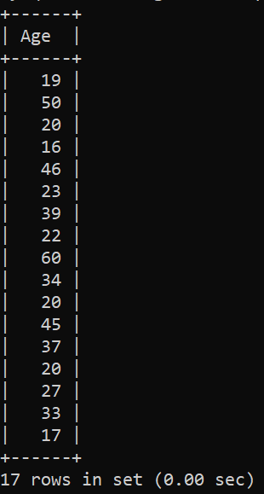

1. mysql> select Gender,Country_Name from Population where Age<33;

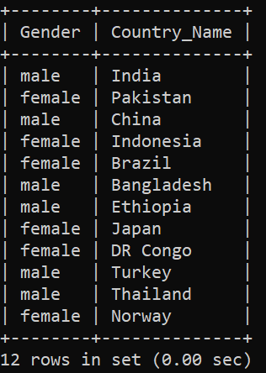

1. mysql> select Name,Occupation from Population where Population<28;

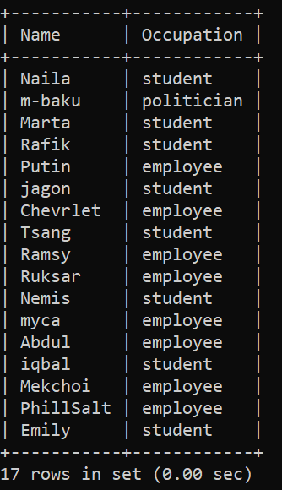

* for grater than equal to:

1. mysql> select * from Population where Age>=22;

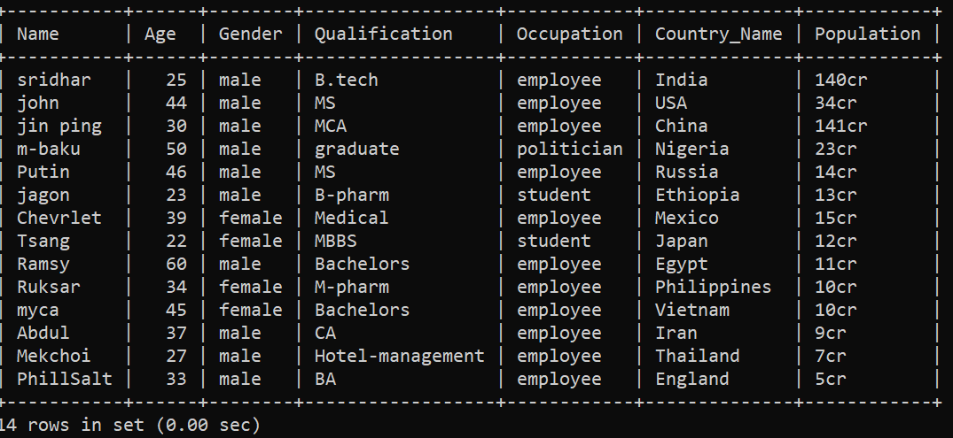

1. mysql> select Name,Population from Population where Age>=22;

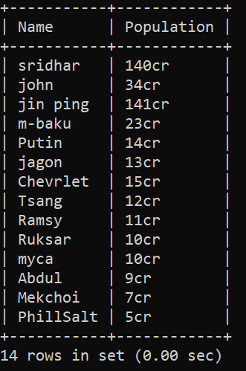

1. mysql> select Gender,Country_Name from Population where Age>=40;

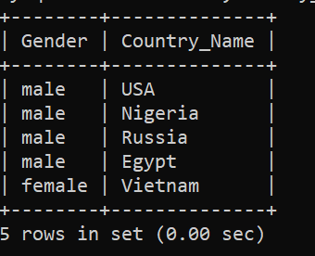

1. mysql> select Name,Population from Population where Age>=18;

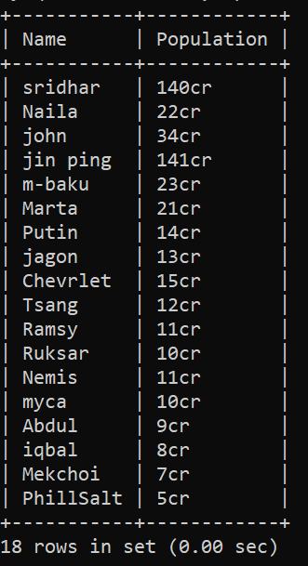

1. mysql> select Qualification,Occupation from Population where Age>=50;

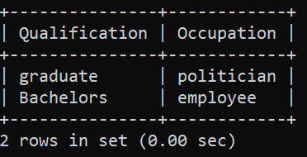

1. mysql> select Age from Population where Population>=25;

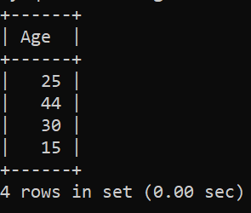

1. mysql> select Age,Gender from Population where Population>=18;

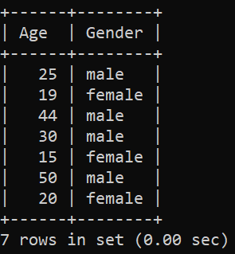

1. mysql> select Population from Population where Age>=25;

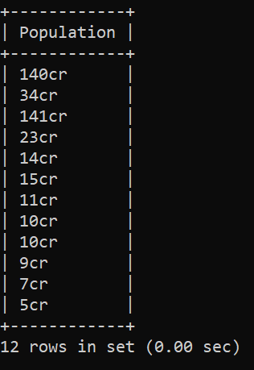

1. mysql> select Name,Country_Name from Population where Age>=35;

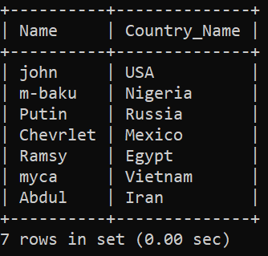

1. mysql> select Qualification from Population where Age>=35;

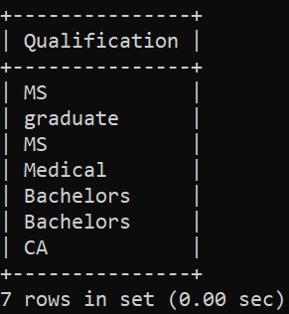

* less than equal to:

1. mysql> select * from Population where Age<=22;

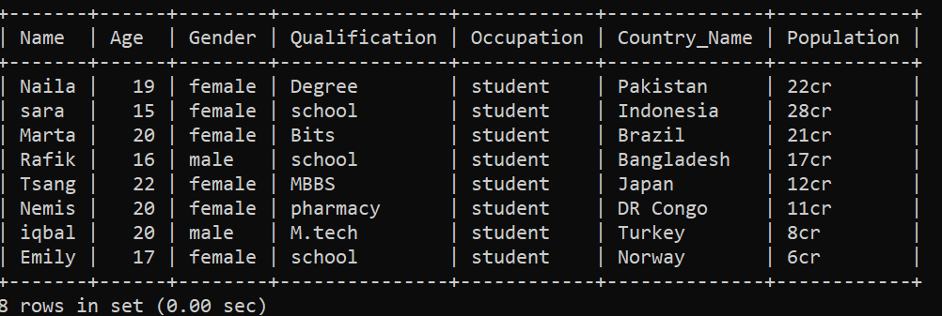

1. mysql> select Name,Population from Population where Age<=22;

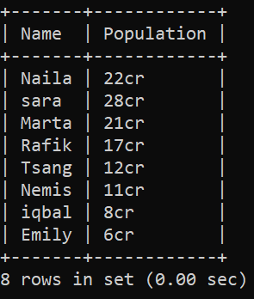

1. mysql> select Gender,Country_Name from Population where Age<=40;

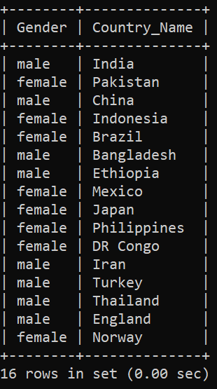

1. mysql> select Name,Population from Population where Age<=18;

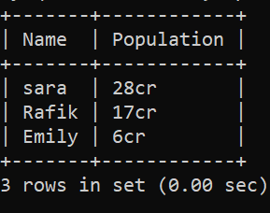

1. mysql> select Qualification,Occupation from Population where Age<=50;

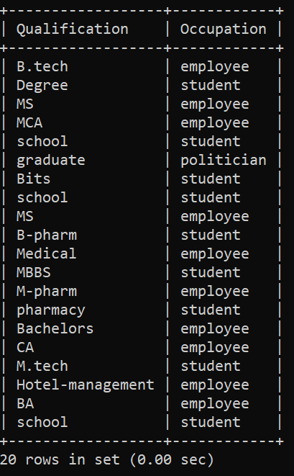

1. mysql> select Age from Population where Population<=25;

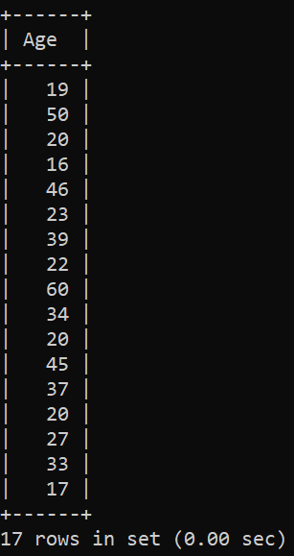

1. mysql> select Age,Gender from Population where Population<=18;

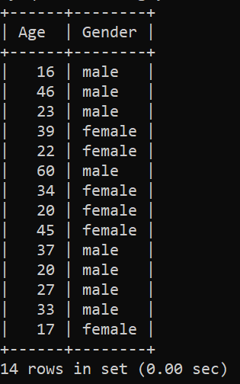

1. mysql> select Population from Population where Age<=25;

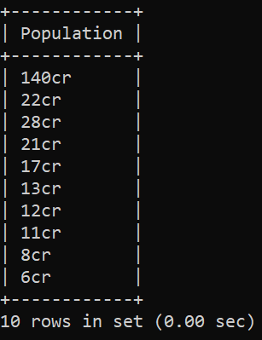

1. mysql> select Name,Country_Name from Population where Age<=35;

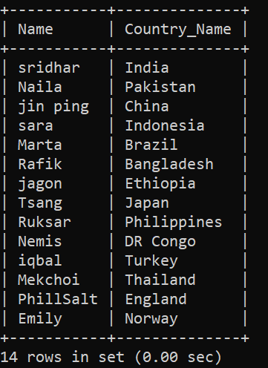

1. mysql> select Qualification from Population where Age<=35;

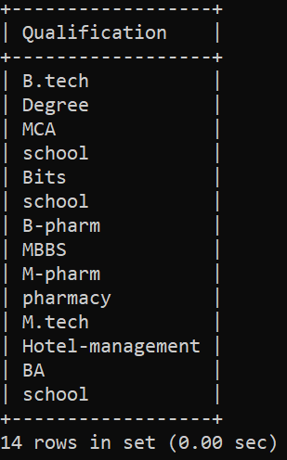

* not equal to:

1. mysql> select * from Population where Age!=22;

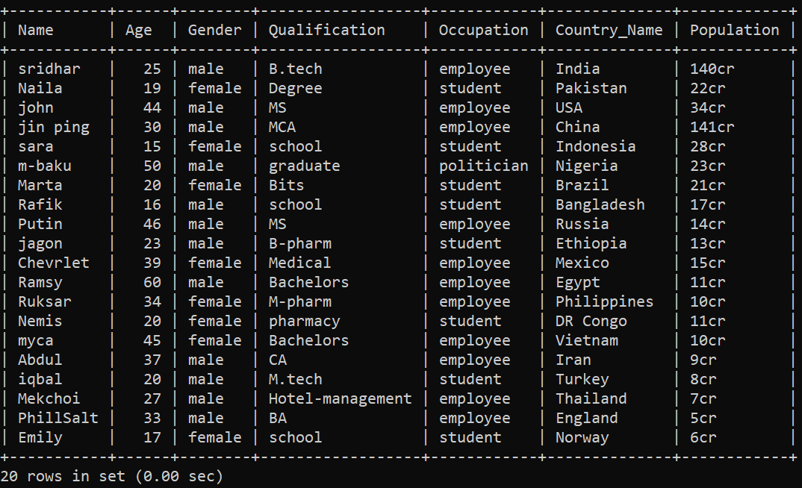

1. mysql> select Name,Population from Population where Age!=22;

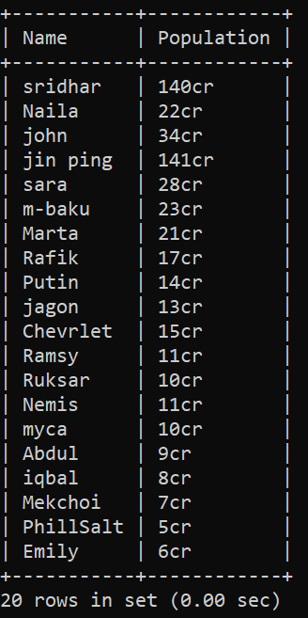

1. mysql> select Age from Population where Occupation!='employee';

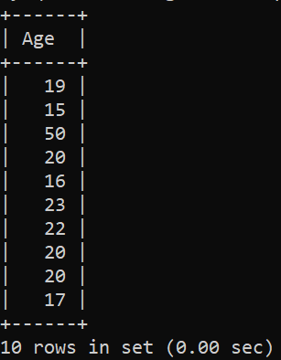

1. mysql> select Age from Population where Gender!='male';

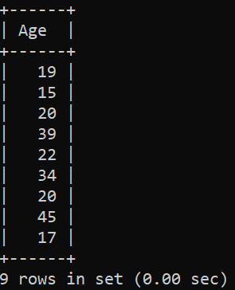

1. mysql> select Country_Name,Population from Population where Gender!='female';

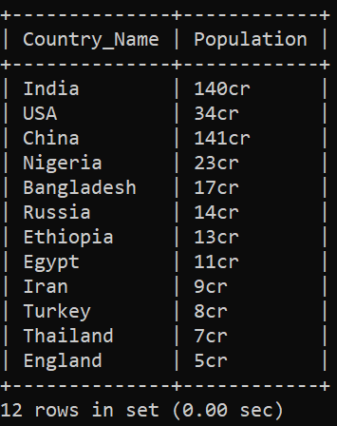

1. mysql> select Gender from Population where Occupation !='student';

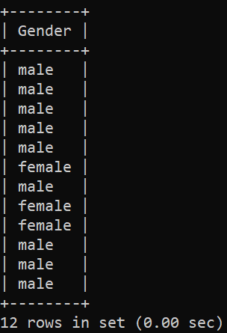

1. mysql> select Qualification from Population where Occupation !='employee';

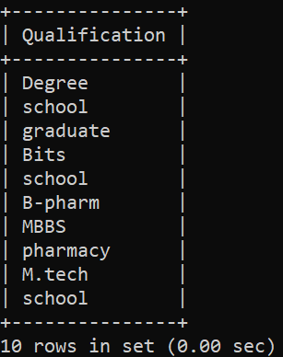

1. mysql> select Age,Population from Population where Occupation !='employee';

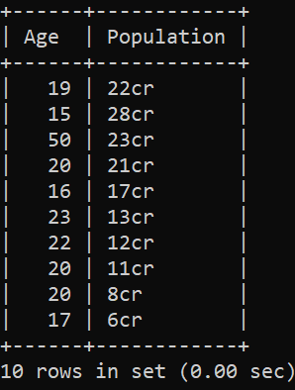

1. mysql> select Country_Name from Population where Age!=50;

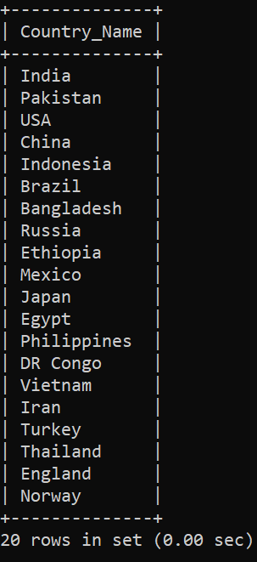

1. mysql> select Age,Population from Population where Occupation !='student';

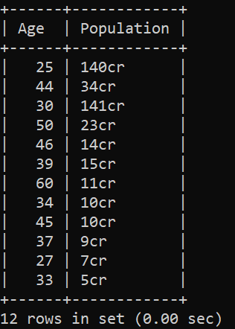

* for Between:

1. mysql> select * from Population where Age between 20 AND 30;

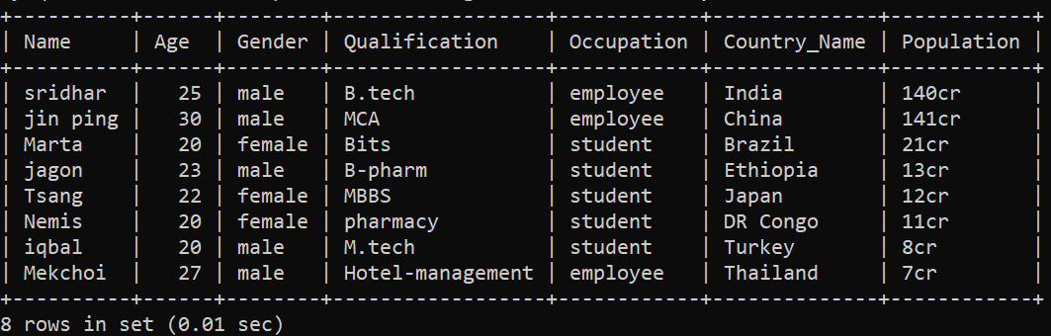

1. mysql> select Name,Gender from Population where Age between 20 AND 30;

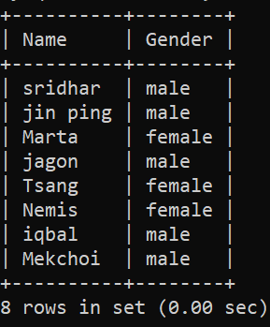

1. mysql> select Population from Population where Age between 30 AND 40;

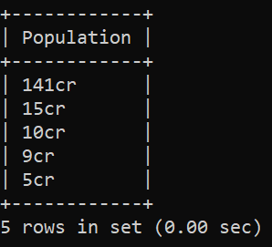

1. mysql> select Country_Name from Population where Population between 20 AND 140;

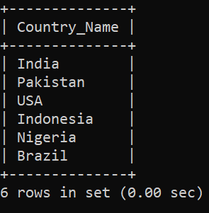

1. mysql> select Country_Name from Population where Age between 15 AND 40;

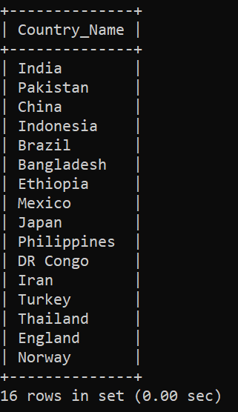

1. mysql> select Occupation from Population where Age between 18 and 40;

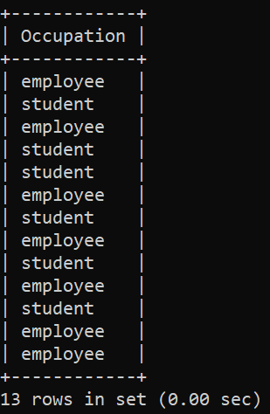

1. mysql> select Gender from Population where Age between 18 and 40;

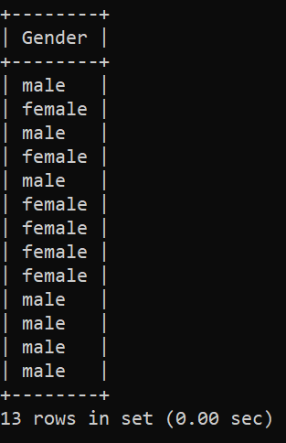

1. mysql> select Gender,Name from Population where Population between 6 and 20;

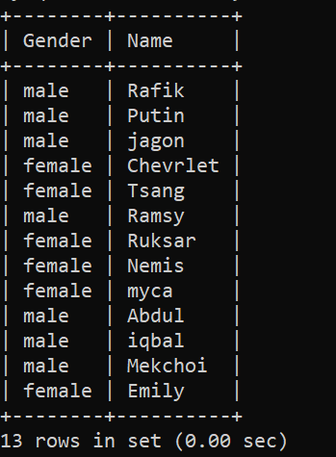

1. mysql> select Occupation from Population where Population between 15 and 35;

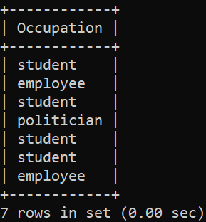

1. mysql> select Qualification from Population where Population between 6 and 20;

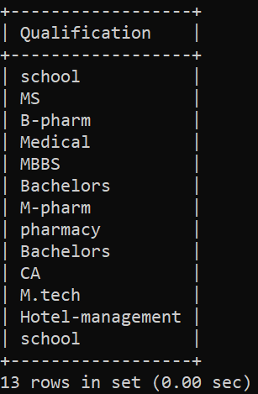

* for in: used fetch either of given conditions.

1. mysql> select * from Population where Country_Name in ('Paris','China');

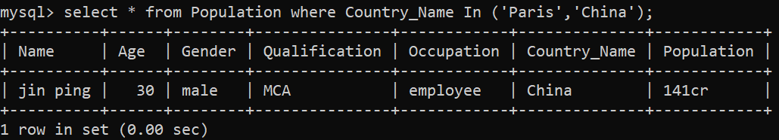

1. mysql> select Name from Population where Occupation in ('employee','student');

Retrieves all names where occupation is **either 'employee' or 'student'**.

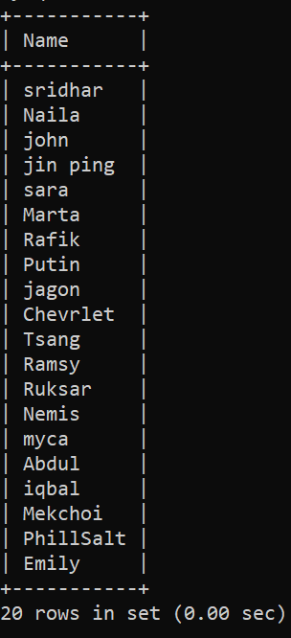

1. mysql> select product_name from inventory where price in(500,4000);

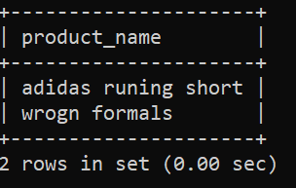

1. mysql> select country_number,country_name from country where capital in ('delhi','kangaroo','peru');

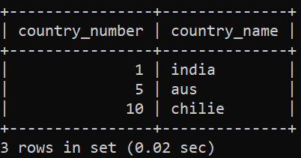

1. mysql> select user_id,email from Authentication where password in('jagan','reddy');

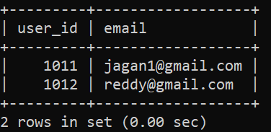

1. mysql> select Age from Population where Gender in('male','female');

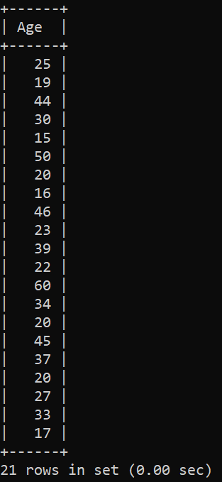

1. mysql> select Age from Population where Country_Name in('India','USA');

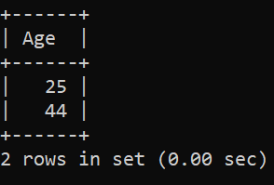

1. mysql> select Qualification from Population where Country_Name in('India','USA');

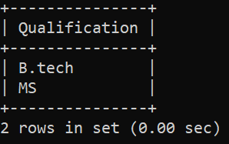

1. mysql> select Gender,Name from Population where Country_Name in('Philippines','Mexico');

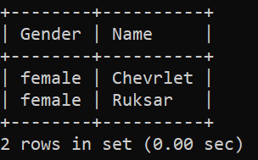

1. mysql> select Gender,Name from Population where Qualification in('MS','Bachelors');

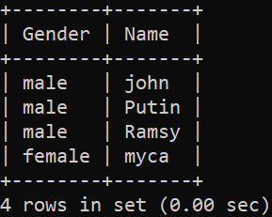

Where clause using Logical operators:

*AND*:

Eg:1) mysql> select * from Population where Age>=18 and Population>50;

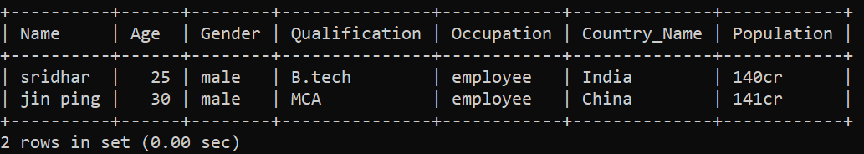

2) mysql> select Name,Occupation from Population where Age<50 and Population<140 and Age>20 ;

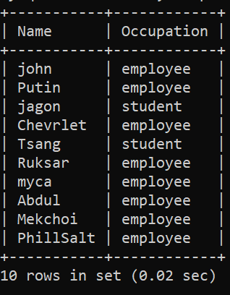

3) mysql> select Name,Occupation,Qualification from Population where Age<=30 and Age>18;

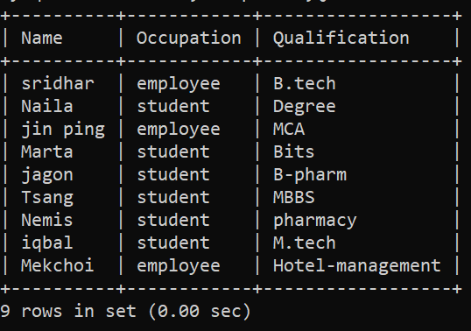

4) mysql> select Age,Occupation from Population where Qualification='Bachelors' and Gender='male';

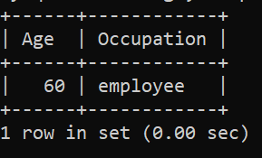

1. mysql> select Gender,Population from Population where Occupation='employee' and Age>30;

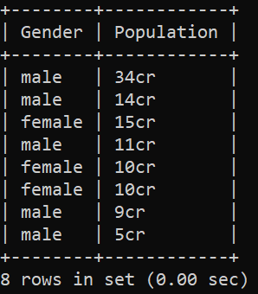

1. mysql> select distinct Population from Population where Age>40 and Gender='female';

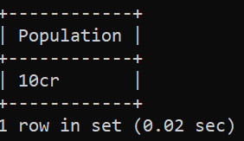

1. mysql> select distinct Population from Population where Age>40 and Gender='male';

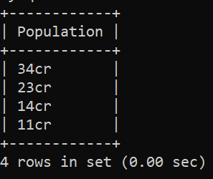

1. mysql> select product_name from inventory where price<3000 and prod_id=5;

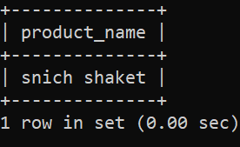

1. mysql> select * from Population where Gender='female' and Population<140;

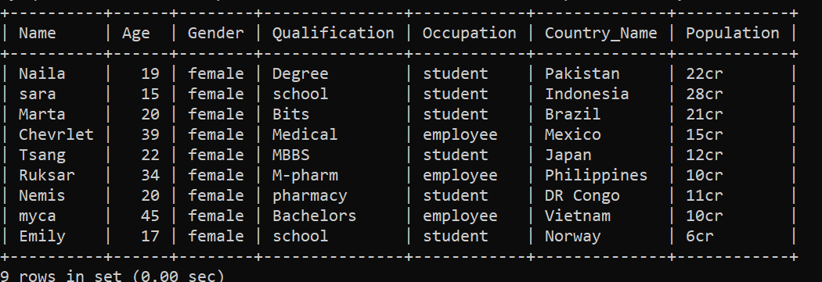

*OR:*

Eg :1) mysql> select * from Population where Age>=18 or Population>50;

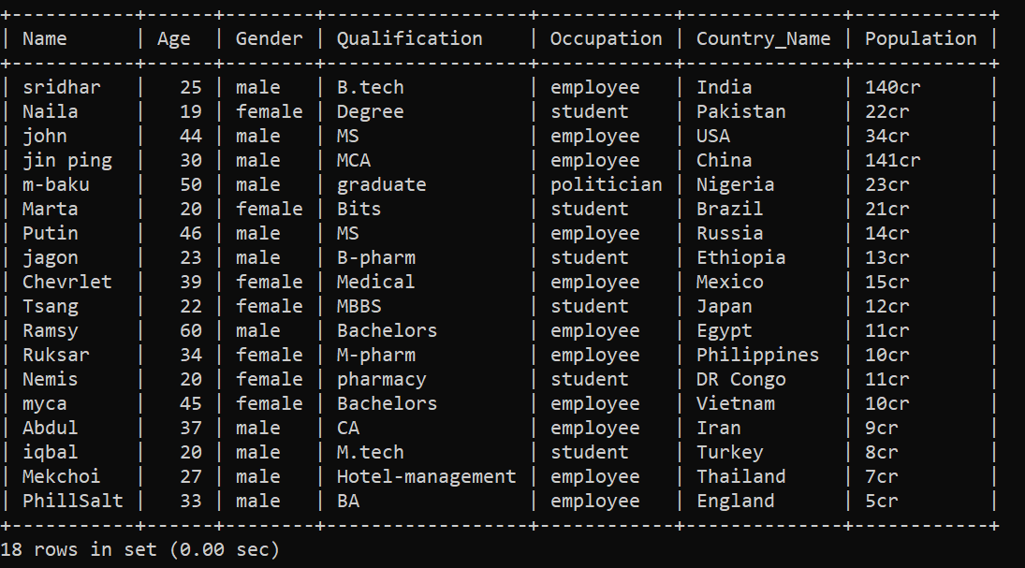

2) mysql> select Gender,Population from Population where Occupation='employee' or Age>30;

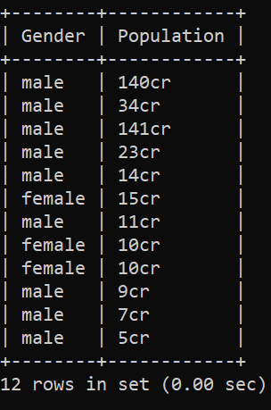

3) mysql> select Age,Occupation from Population where Qualification='Bachelors' or Gender='male';

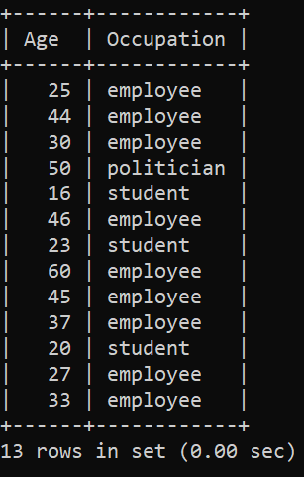

4) mysql> select Name,Occupation,Qualification from Population where Age<=30 or Age>18;

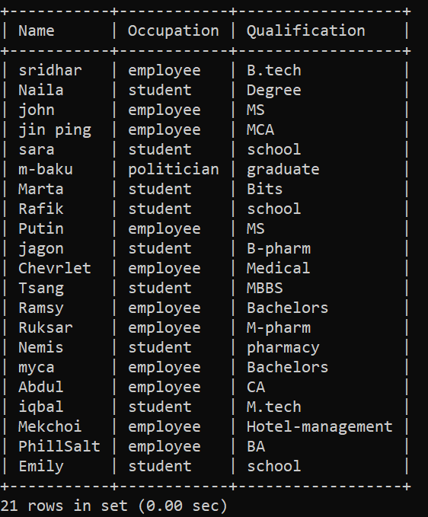

5)mysql> select Name,Occupation from Population where Age<50 and Population<140 or Age>20 ;

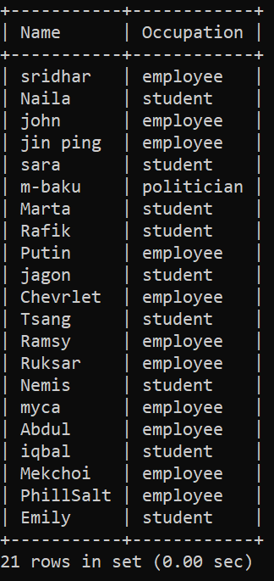

6) mysql> select Name from Population where Age=20 or Gender='male';

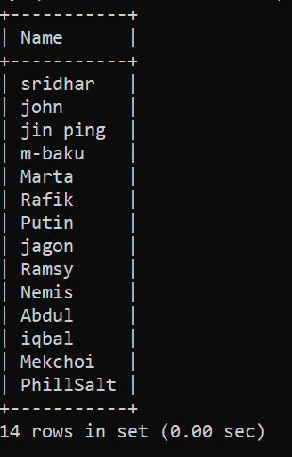

7) mysql> select * from Population where Gender='female' or Population<140;

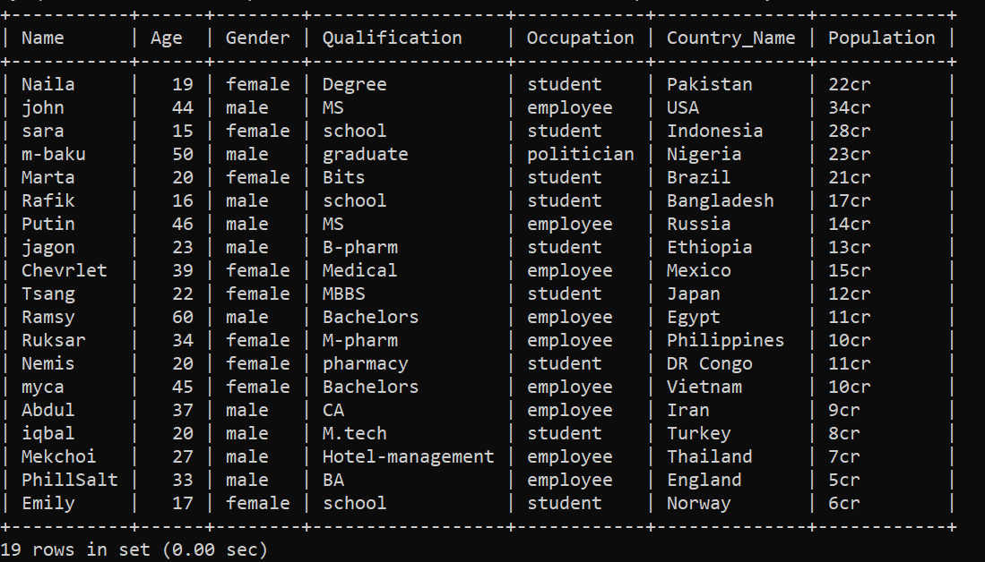

8) mysql> select product_name from inventory where price<3000 or prod_id=5;

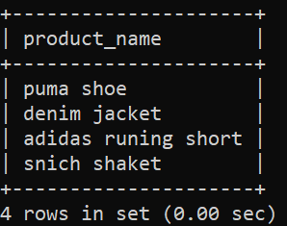

9) mysql> select distinct Population from Population where Age>40 or Gender='male';

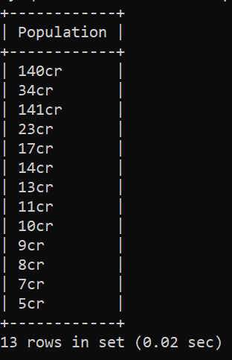

10) mysql> select distinct Population from Population where Age>40 or Gender='female';

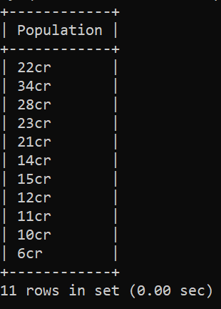

*NOT:*

Eg: 1) mysql> select * from Population where not Age>=18;

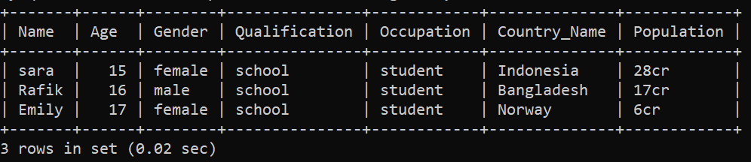

2) mysql> select Name,Gender from Population where not Occupation='employee';

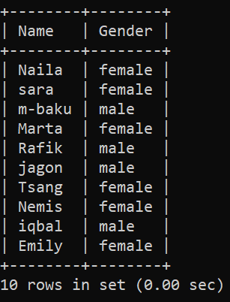

3) mysql> select Name,Gender from Population where not Occupation!='employee';

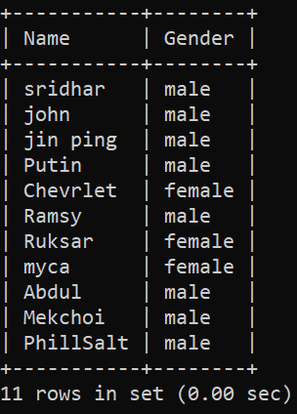

4) mysql> select Age,Country_Name from Population where not Population<140;

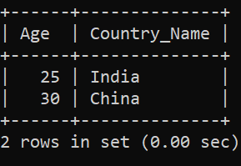

5) mysql> select Name,Occupation from Population where not Age<50 and Population<140 or Age>20 ;

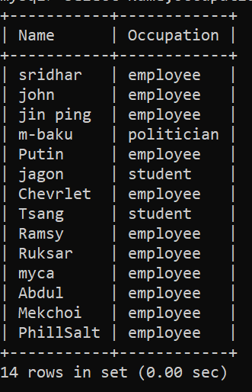

6) mysql> select Country_Name from Population where Population not between 20 AND 140;

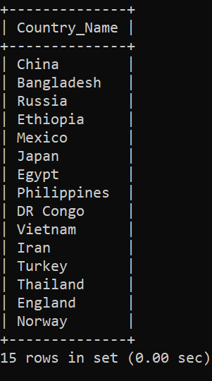

7) mysql> select Population from Population where not Gender='male';

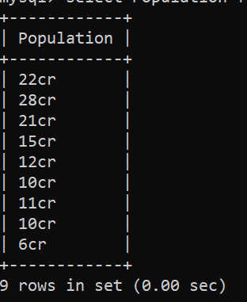

8) mysql> select Population from Population where not Gender!='male';

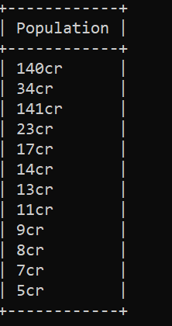

9) mysql> select Population from Population where not Gender!='female';

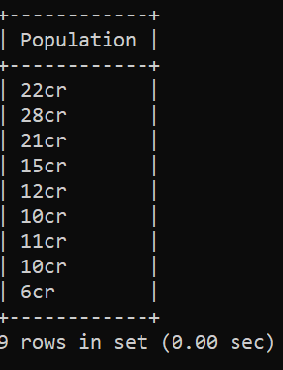

10) mysql> select Population from Population where not Gender='female';

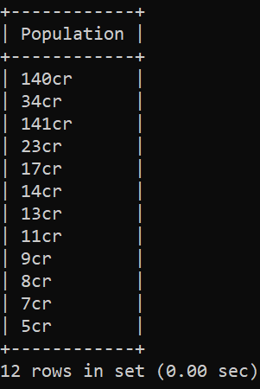

DDL & DML commands :-

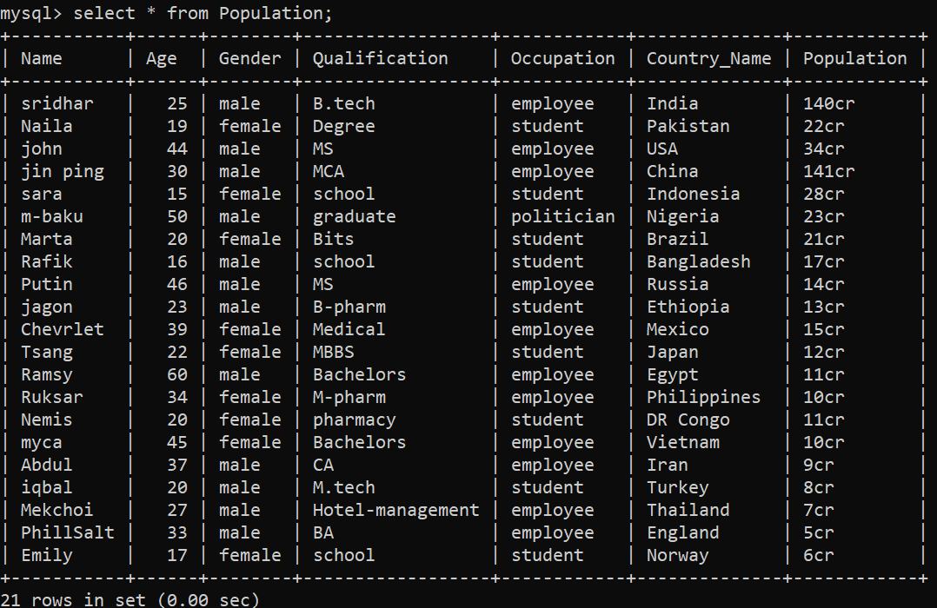

1. *drop* : deletes data from tables.

Syntax ; drop table table-name

1. drop table inventory;



1. drop table states;



1. drop table employe1;

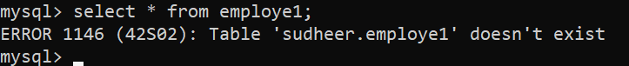

1. drop table customer_order;



1. *alter* : alters the structure of database.

Syntax ; alter table table-name add column column-name datatype.

1. mysql> alter table Population add column alive varchar(10);

Query OK, 0 rows affected (0.14 sec)

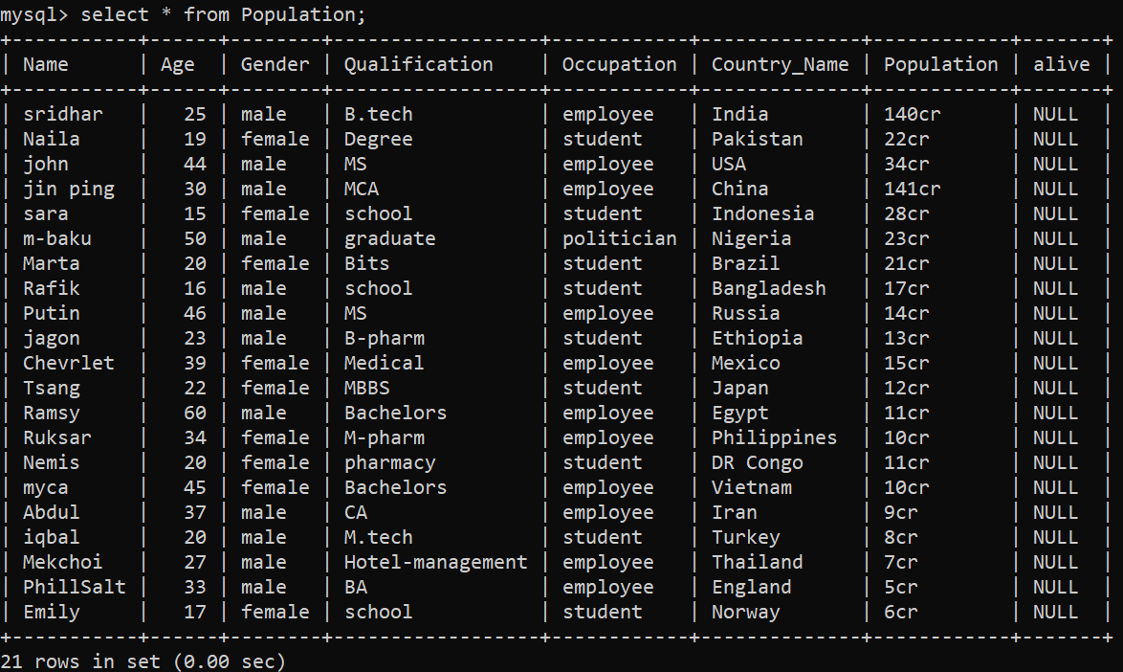

Here showing null bcs we didn’t insert any values

1. alter table inventory add column rating int;

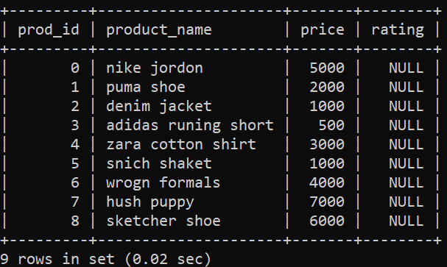

1. alter table customer_order add column date int(19);

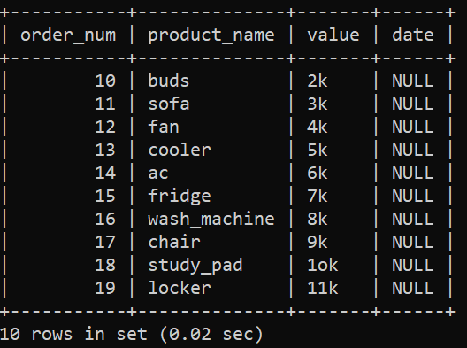

1. alter table employe1 add column duty varchar(29);

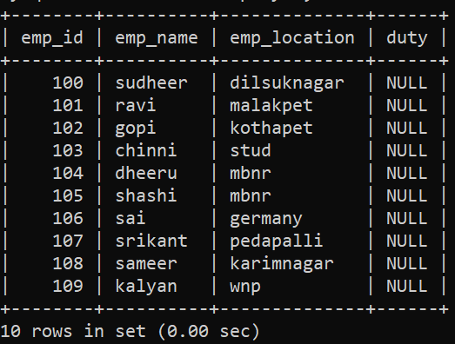

1. alter table states add column known_names varchar(20);

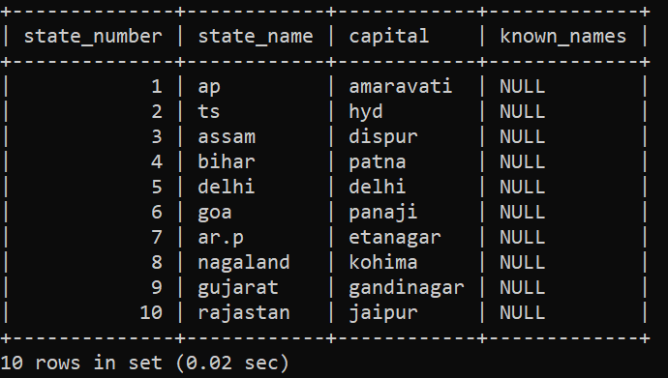

1. *Truncate* : it removes all the records from table.

Syntax ; truncate table table-name;

1. truncate table Authentication;

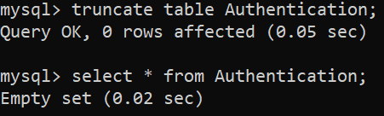

1. truncate table inventory;
2. truncate table customer_order;



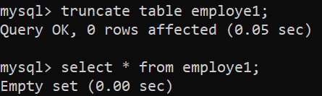

1. truncate table states;

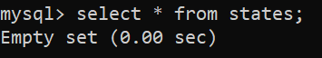

1. *Comment* : adds comment to the data dictionary.

Syntax ; comment ‘comment-text’ on table table-name;

1. alter table Population comment='a deep researched data';

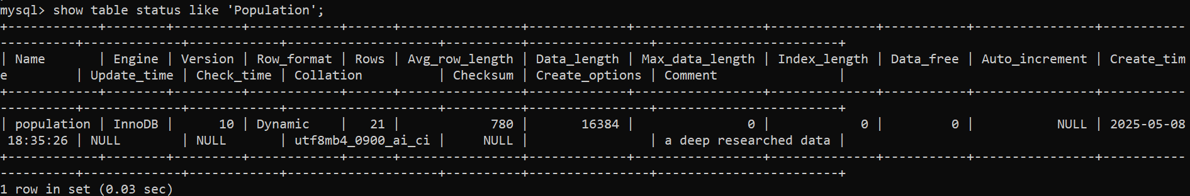

1. *Rename* : renames the existing table.

Syntax ; rename table old-table-name to new-table-name;

1. rename table Population to World_Population;



1. *Insert* : inserts data into table.

*Update* :

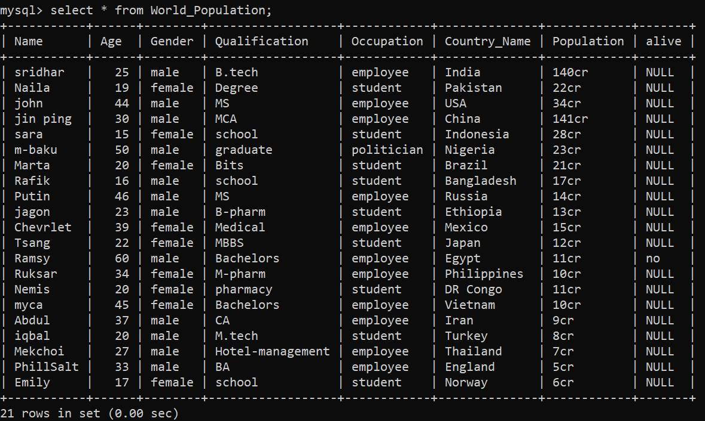

1. update states set known_names='Reddy' where state_name in('ap','ts');

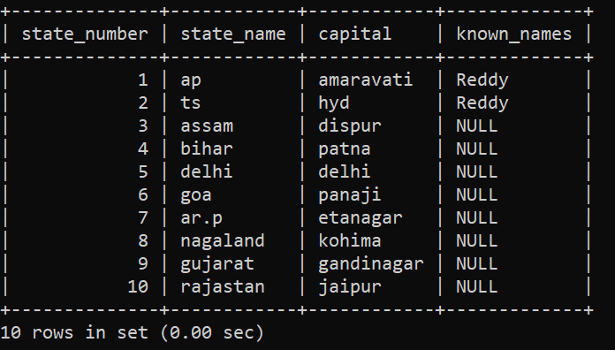

1. update employe1 set duty='asso.s.e' where emp_id=100;

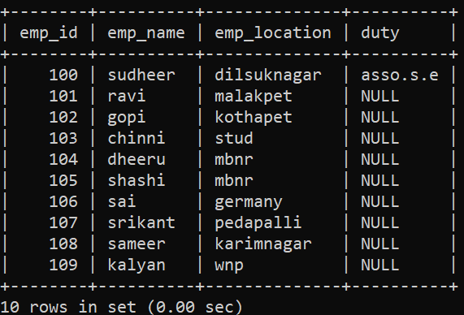

1. update customer_order set date=13-10-25 where order_num=13;

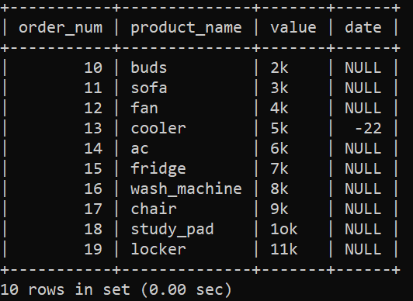 I mean to enter _ but took ’ –‘

1. update inventory set rating=5 where product_name='puma shoe';

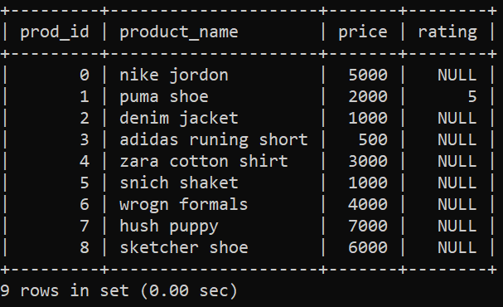

1. delete from World_Population where Name='sridhar';

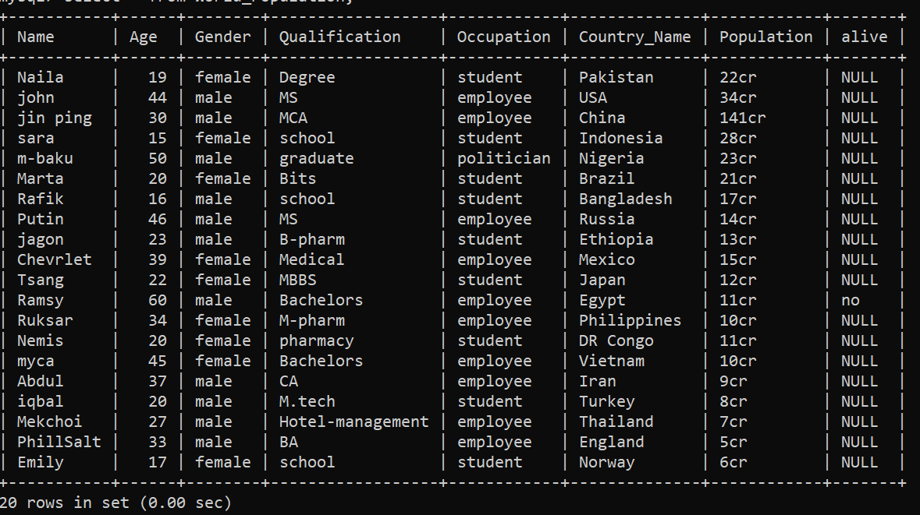

1. delete from World_Population where Gender='female';

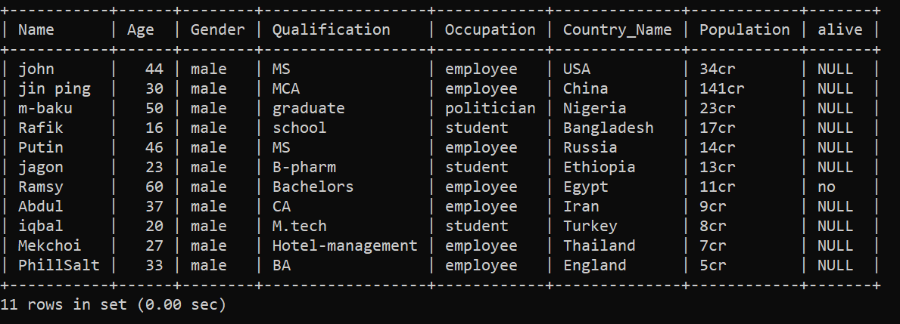

1. delete from World_Population where alive='no';

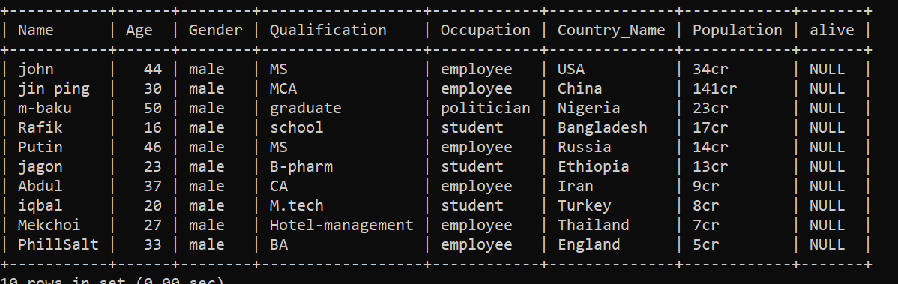

1. delete from Authentication where user_id=1020;

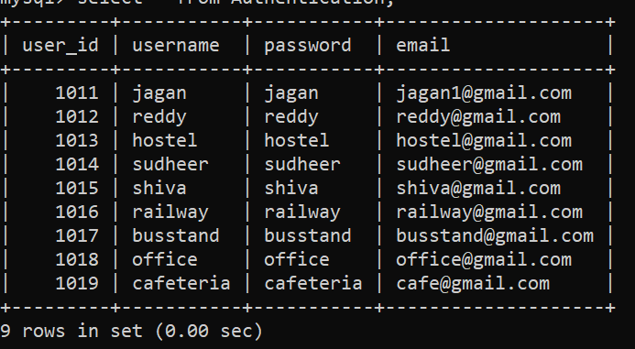

1. delete from Authentication where password='reddy' or user_id=1019;

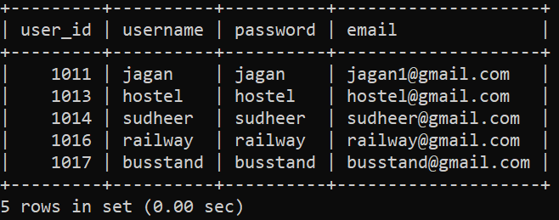

Order by :-

1. Name select,Age from Population order by Age ASC;

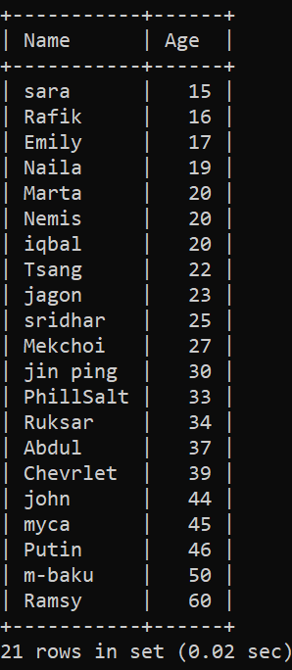

1. select Name,Age from Population order by Age DESC;

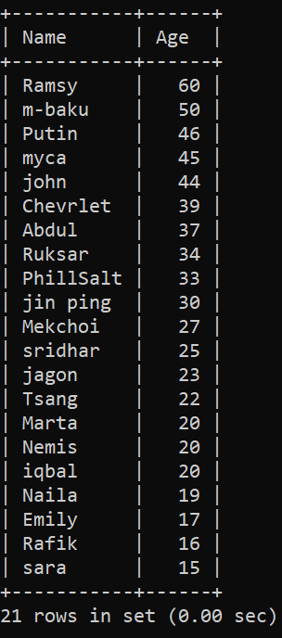

1. select Population from Population order by Population ASC;

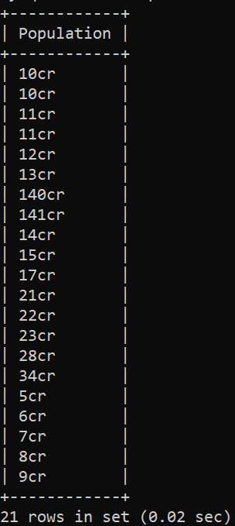 it won’t shows bcs here ‘cr’ added to values.

1. select Gender from Population order by Name DESC;

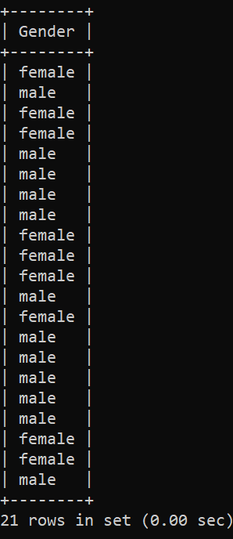 it in compatible with select distinct.

1. select Name,Occupation from Population order by Name ASC;

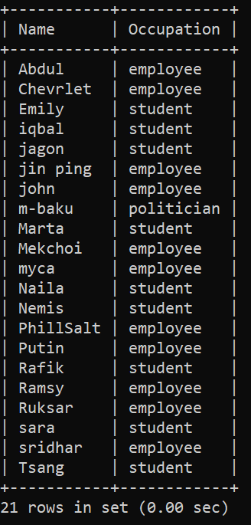

Null values :-

1. select * from Population where health is null;

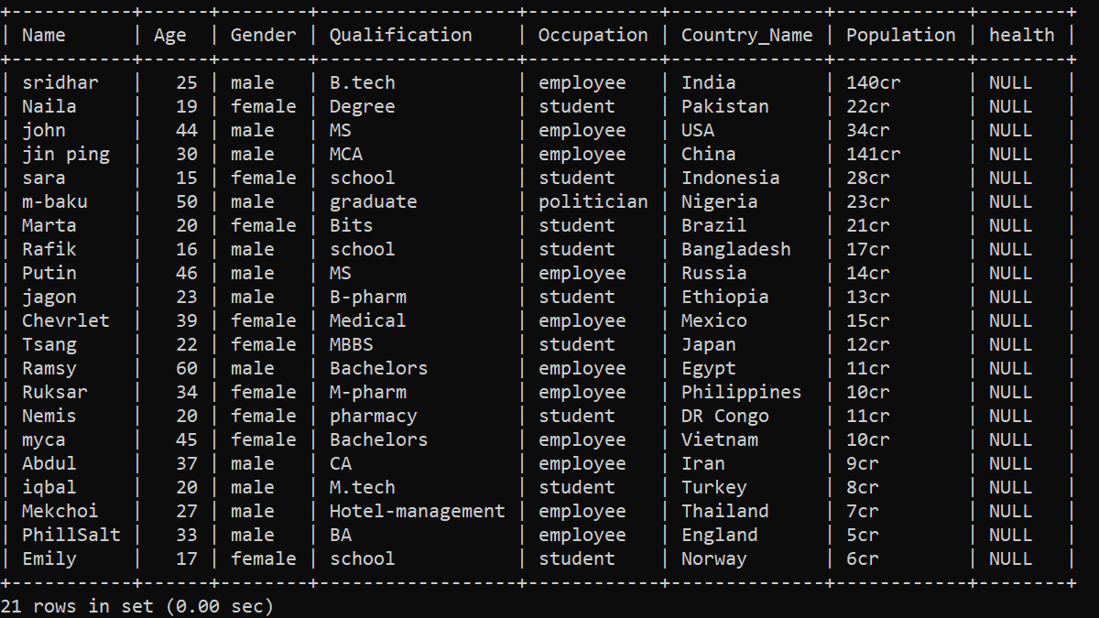

1. select Age from Population where health is null;

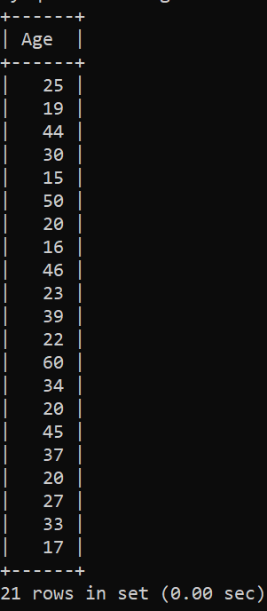

1. select Age from Population where health is not null;



1. update Population set health='ok' where health is null;

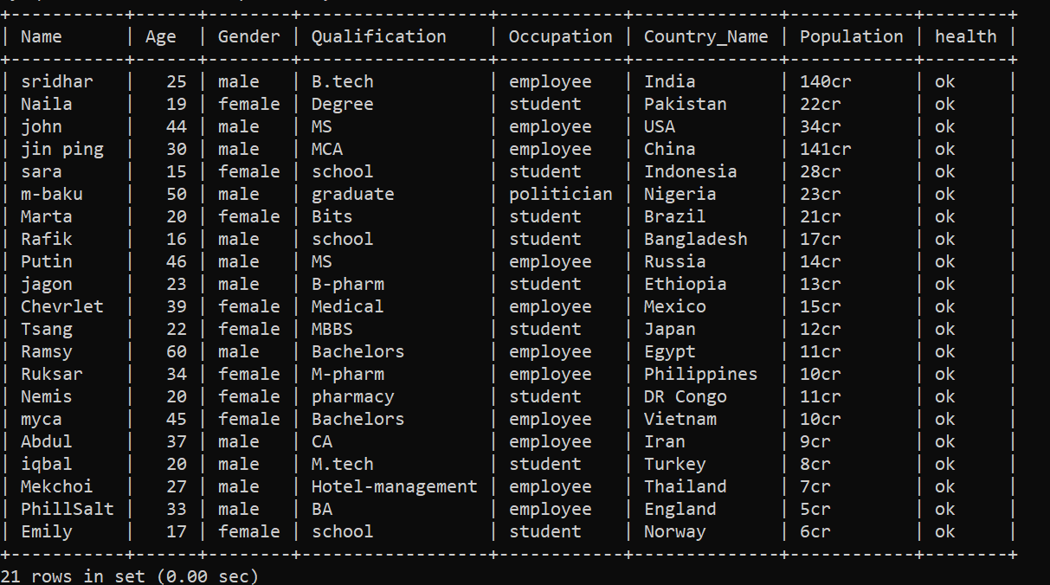

***Limit clause*** :-

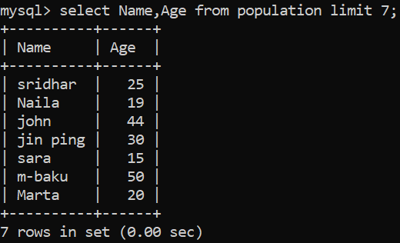

2.

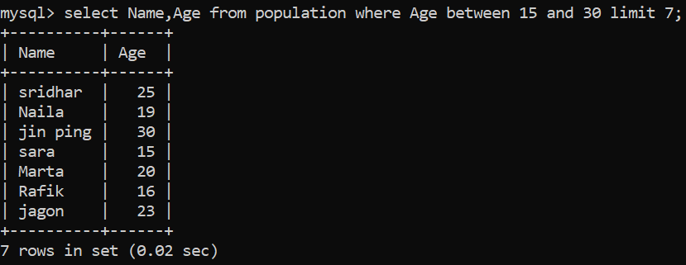

3.

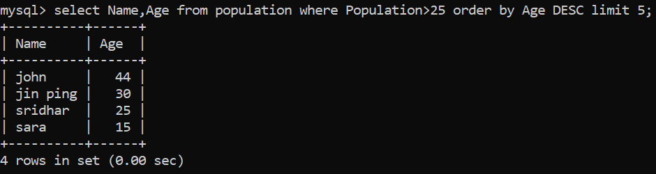

4.

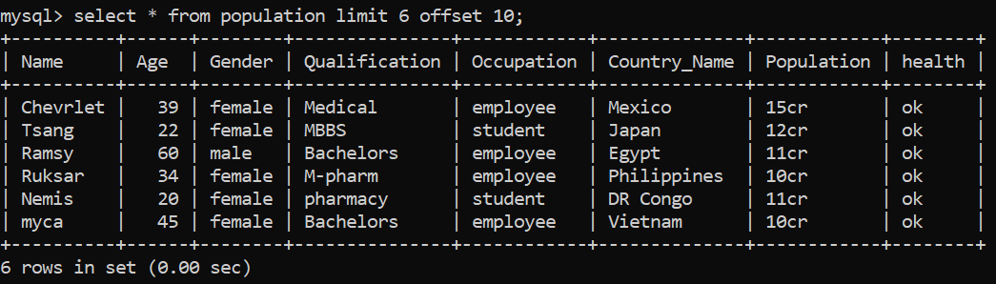

Pagination🡪 here by using offset 10 we can retrieve limit 6 by skipping first 10 rows.

5.

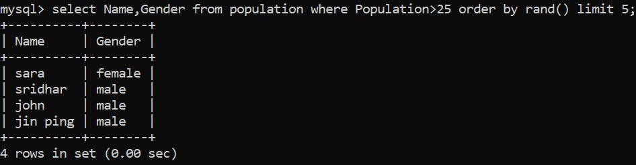

*Min() function*:

1.

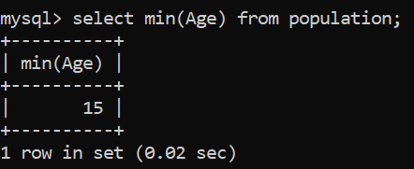

Also : select min(Age) as lowestAge from population;

1. select min(Age) from population where Population; (or)

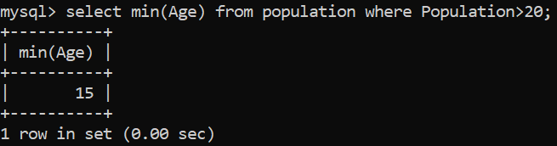

3.

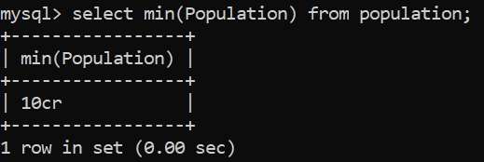

4.For strings like names if we entered min() we get by alphabetical order.

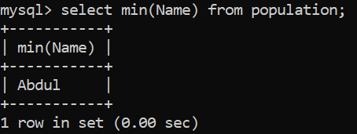

5.

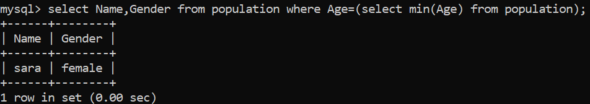

*Max() function* :

1.

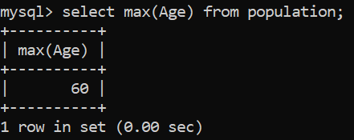 also use: select max(Age) as highestAge from population;

2.

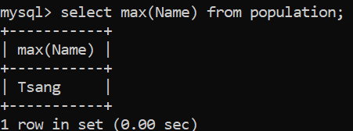 by using string values like names we get alphabetical order by descending order.

3.

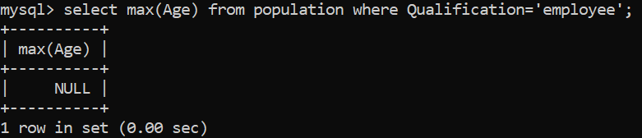

4.

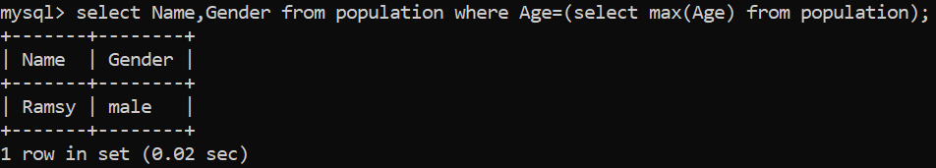

*Count() function* :

1.

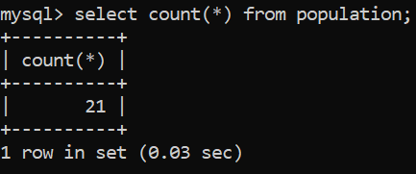

2.

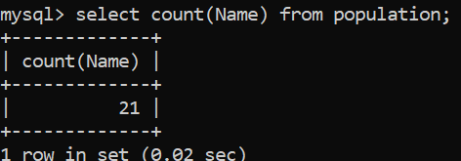

3.

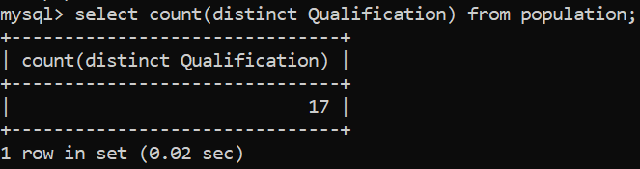 by using distinct here we can select unique values, no duplicates.

4.

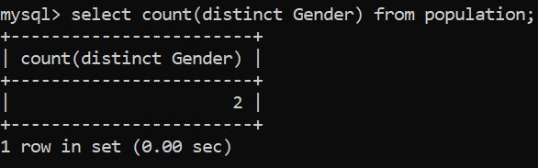

5.

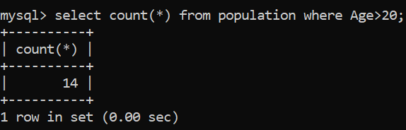

6.

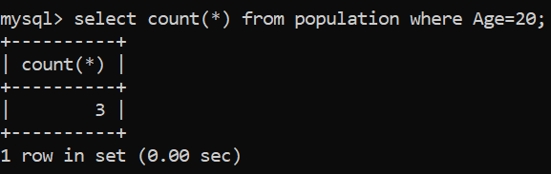

*Avg() function* :

1.

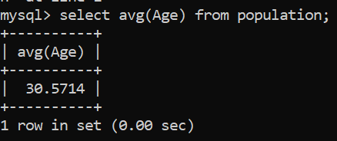

2.

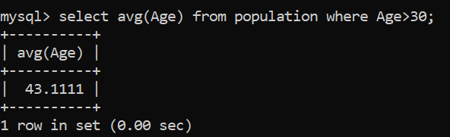

3.

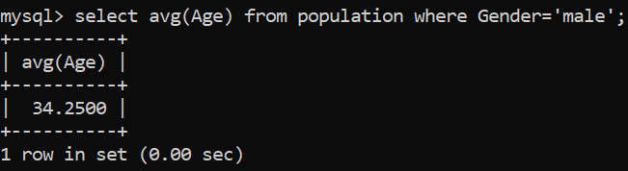

4.

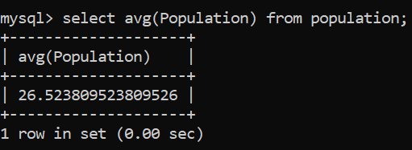

5.

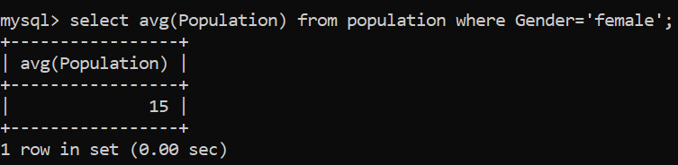

6.

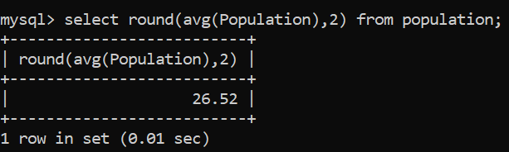

*Sum() function* :

1.

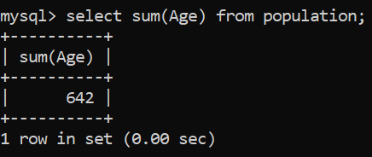

SELECT SUM(Age) AS TotalAge FROM population; can use this syntax also.

2.

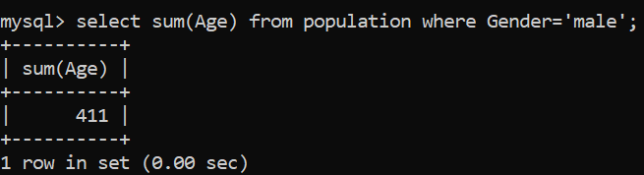

3.

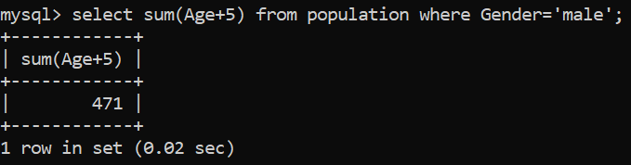

Sum(Age+5) => means it adds num.5 to each & every male ages before going to add all.

4.

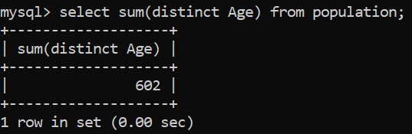

5.

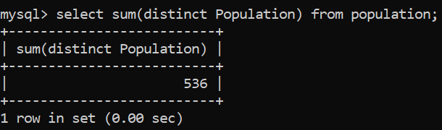

6.

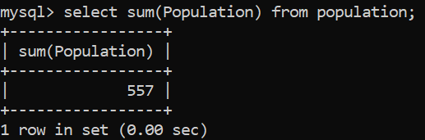

7.

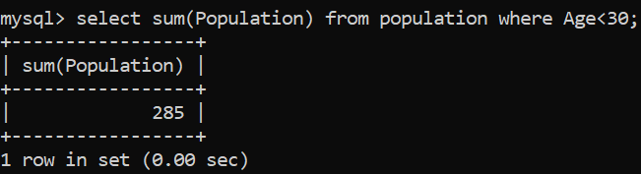

8.

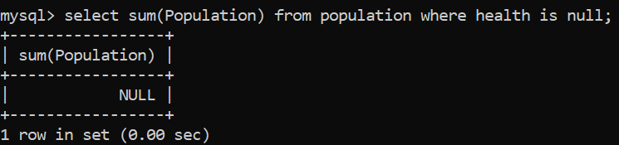

9.

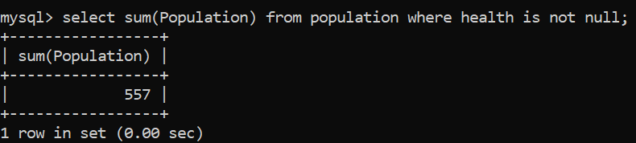

*Like() operator* :

1.

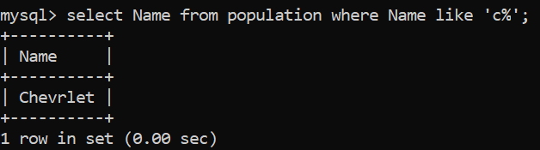

2.



3.

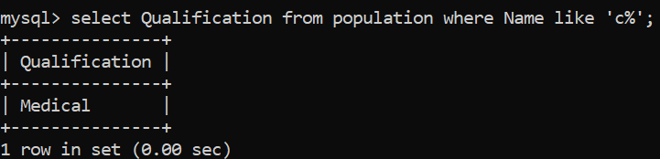

4.



5.

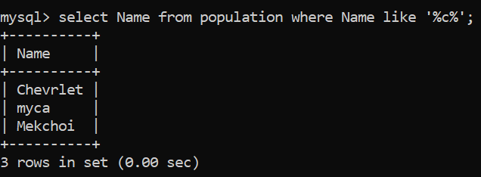

6.

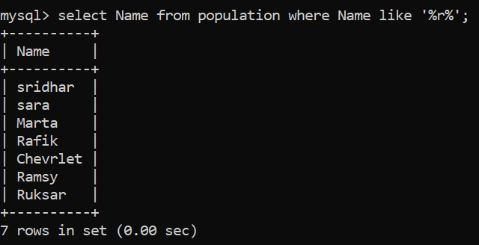

7.

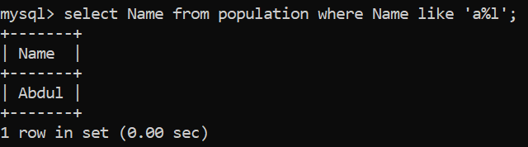

a%l rep. name starts with ‘a’ and ends with ‘l’.

8.

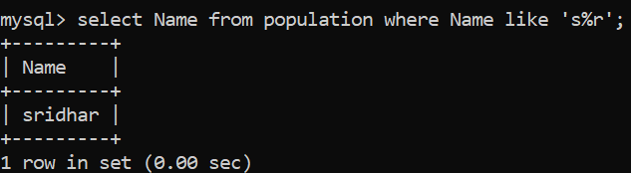

9.

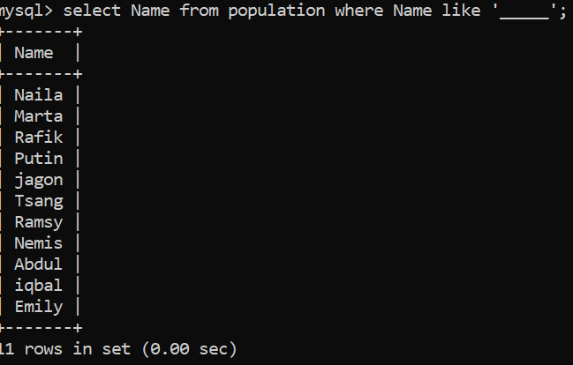

**Join clause** :-

*inner join*

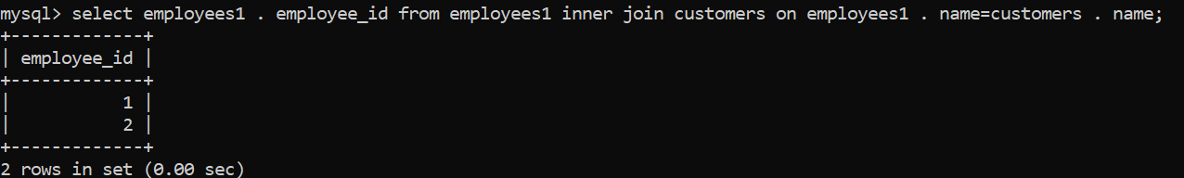

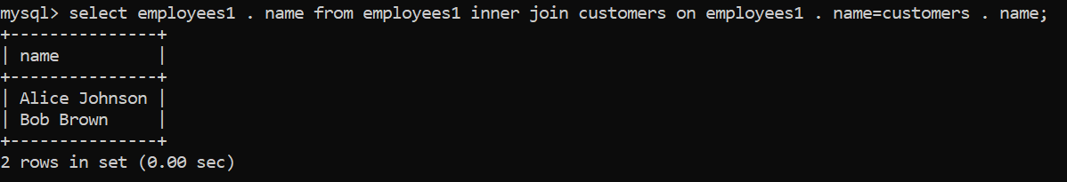

*Left join*

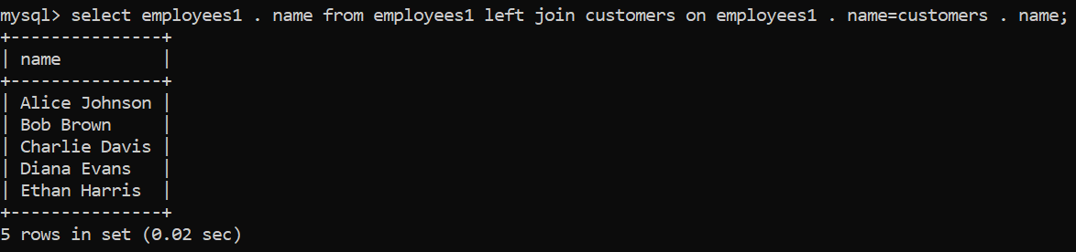

1. *Right join* :

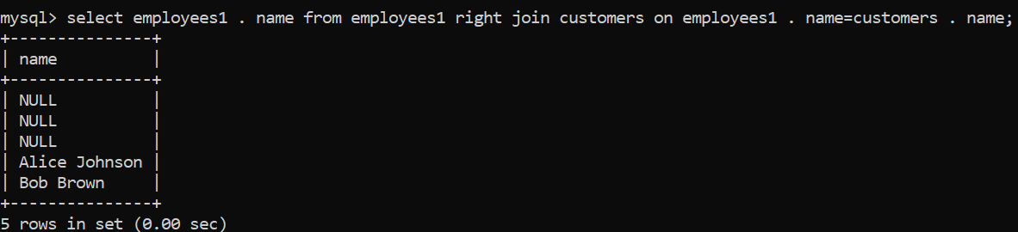

1. *Cross join* : returns all the records from both tables.

Syntax; select column_name from table_name cross join table2;

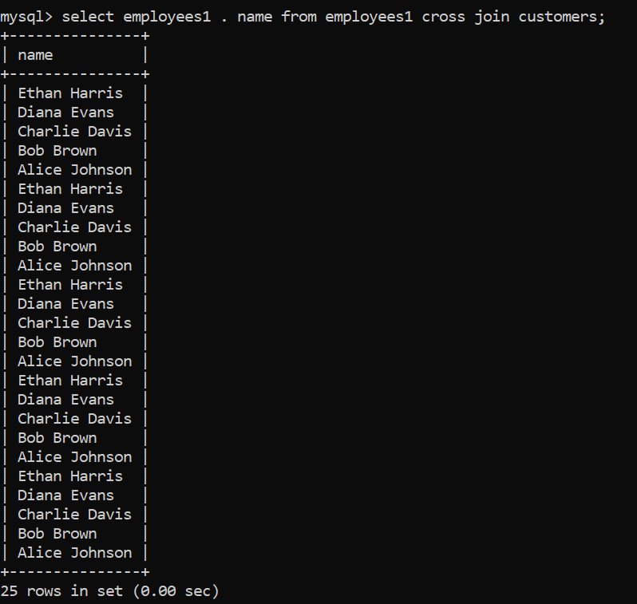

1. *Self join* : a table is joined with it self.

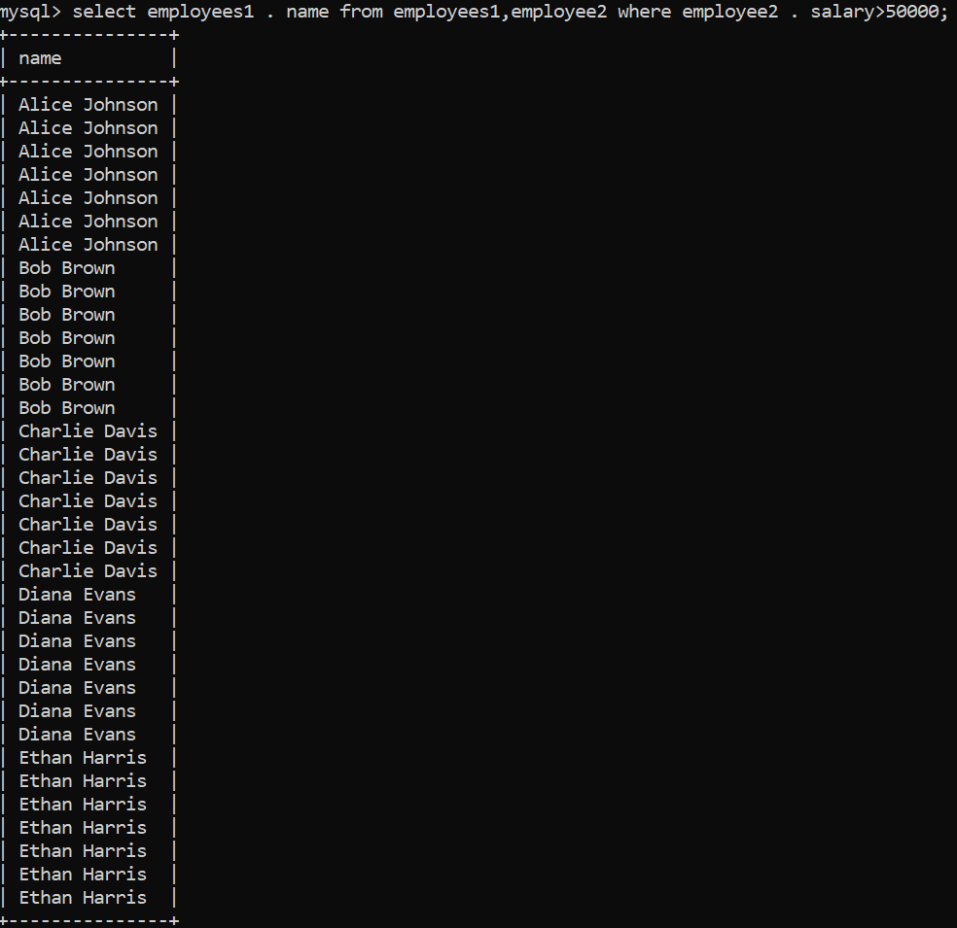



*Union operator* :

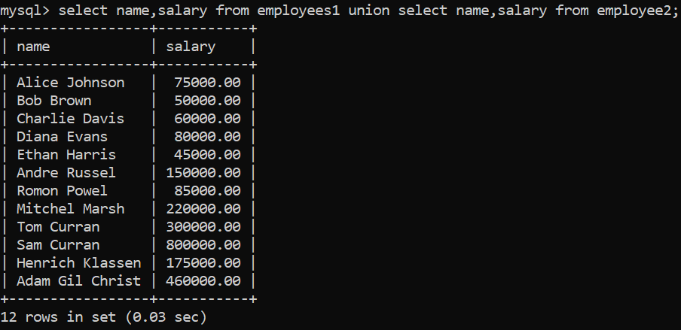

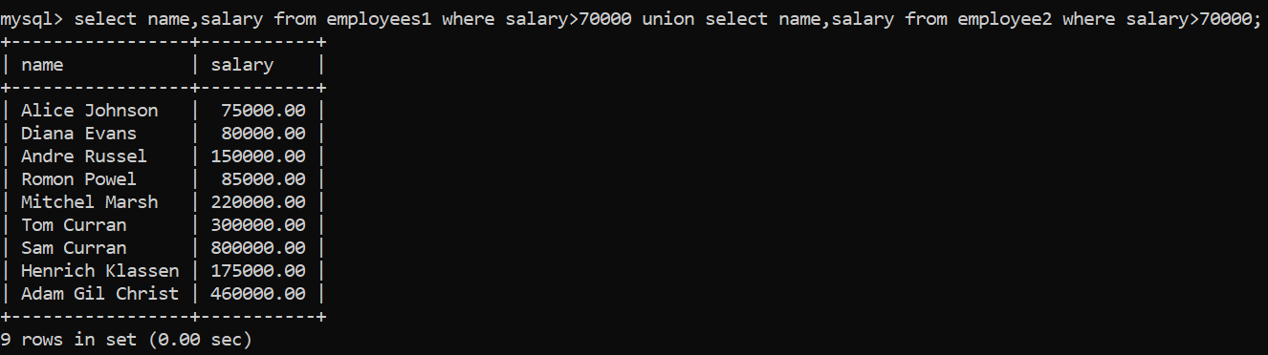

**Group by statement** :-

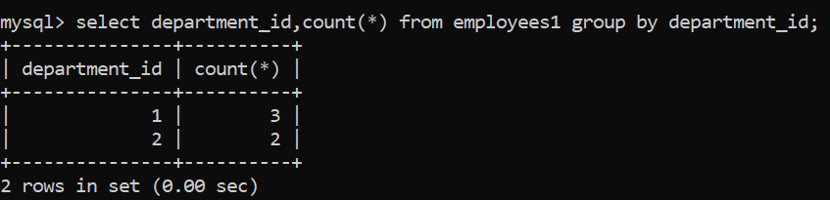

2.

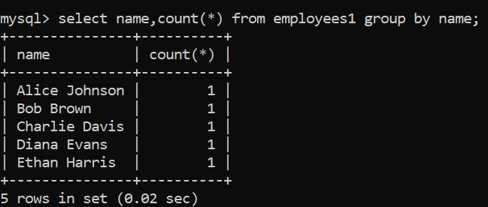

3.calulates average salary for employees under each department_id.

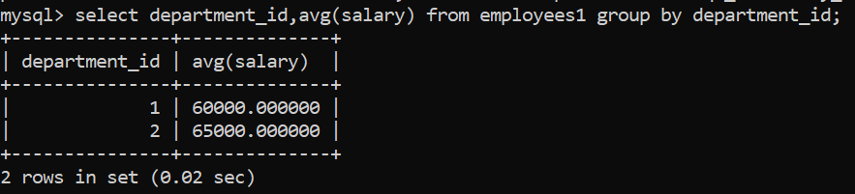

4.

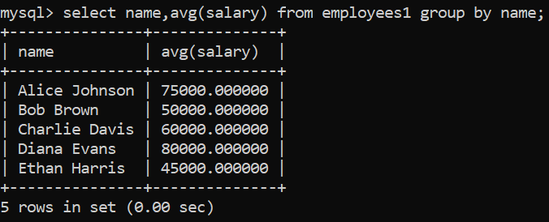

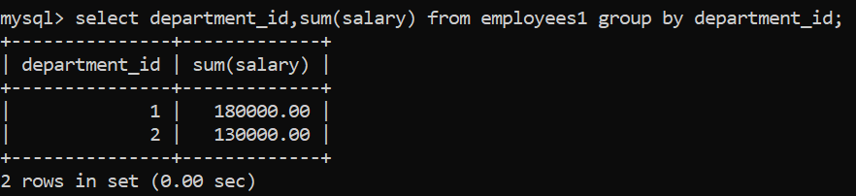

6.

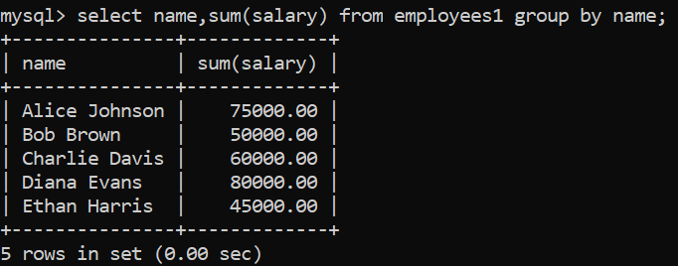

Calculates sum all salaries in each name. by making each name as one group.

7.

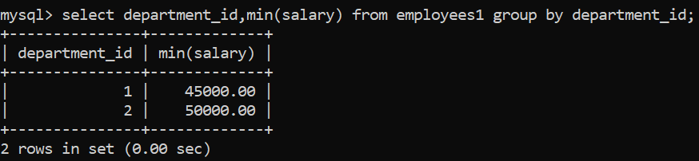

Retrieves lowest salary from each department.

8.

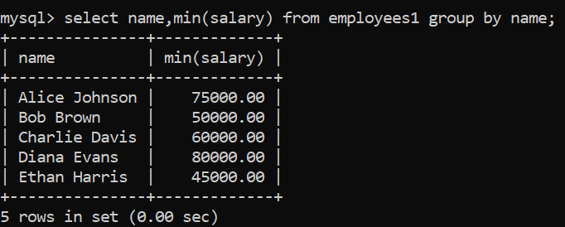

**Having clause** :-

1.



2.

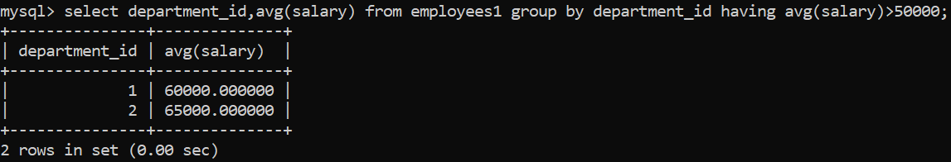

**Exists operator** :-

1.

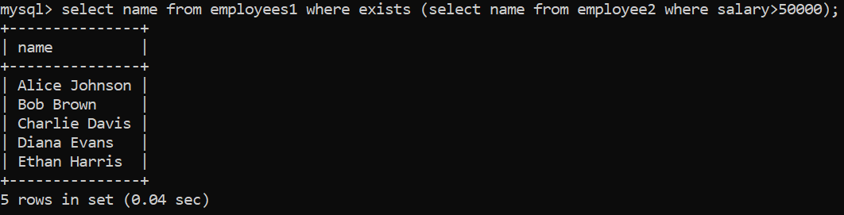

2.

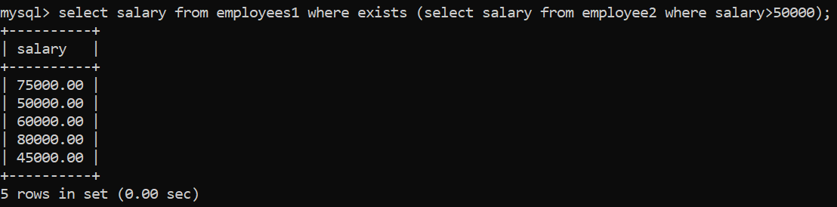

3.



4.

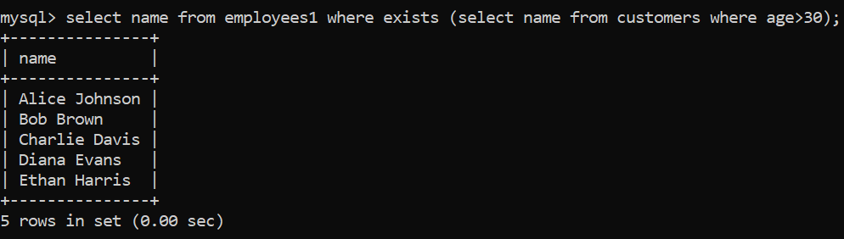

**Any operator** :-

1.

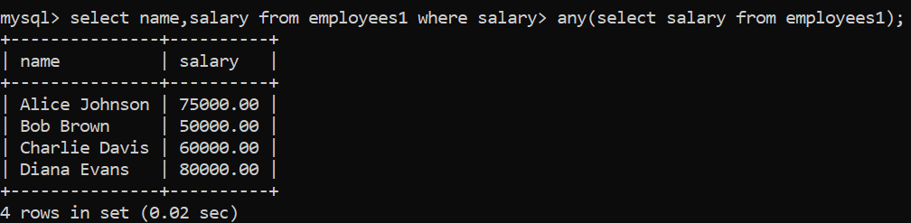

2.

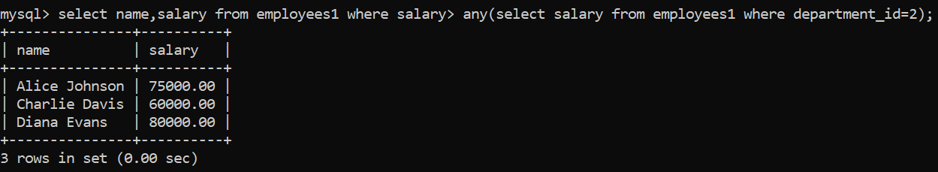

3.



4.

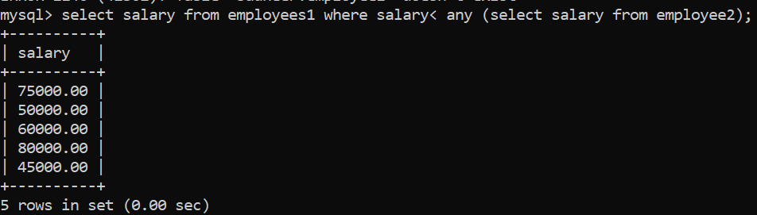

5.

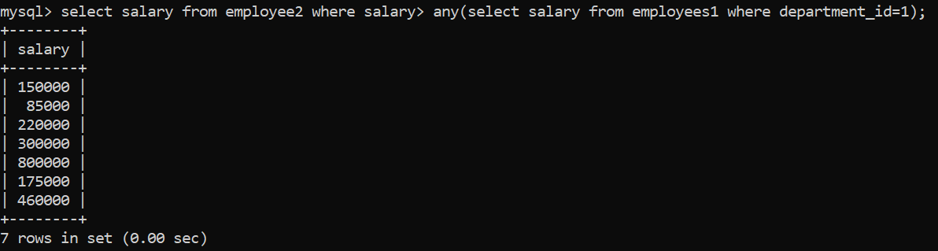

6.



7.

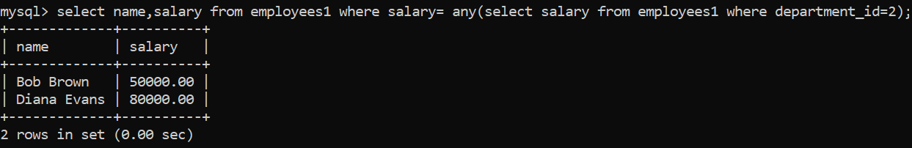

**All operator** :-

2.

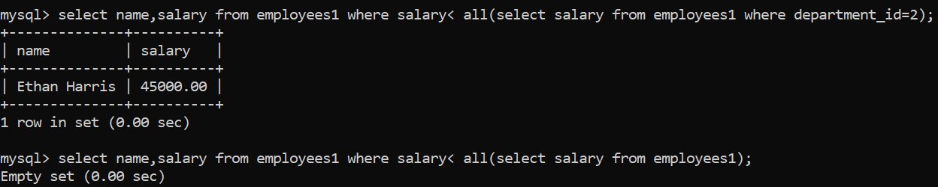

3.

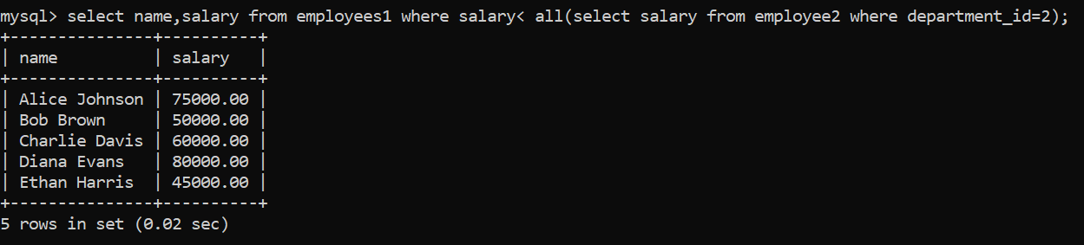

4.

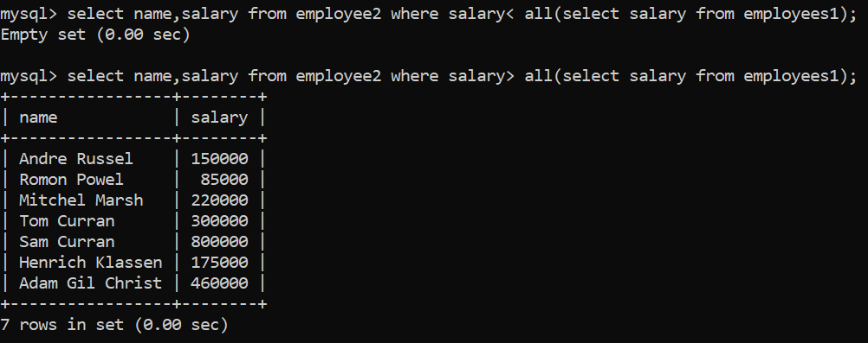

5.

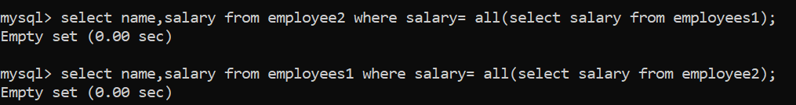

6.

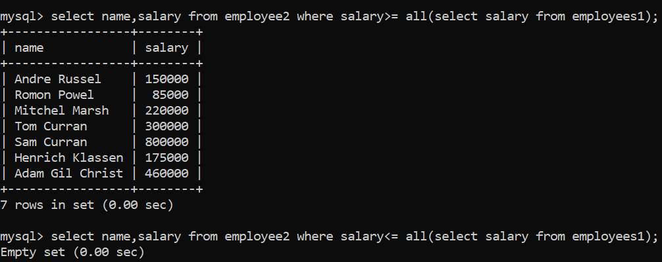

**Index** :

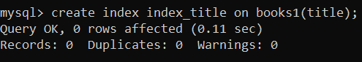

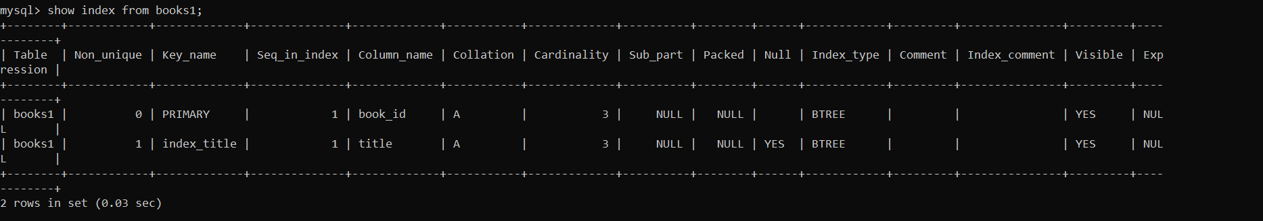

*To create unique index*:

Syntax; create unique index index_name on table_name(col1, col2….);



Unique index throws an error, if you tries to insert duplicate index. Because we already created an index for column “title”.

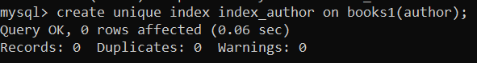

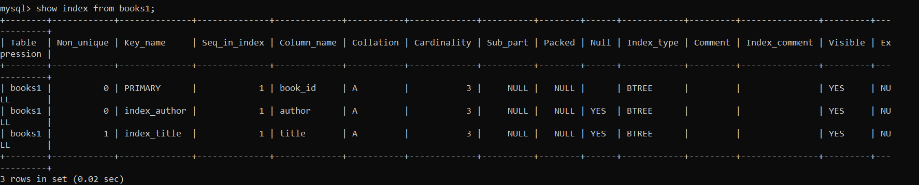

*Drop index* : used to delete the index that was already created on a table.

Syntax; alter table table_name drop index index_name;

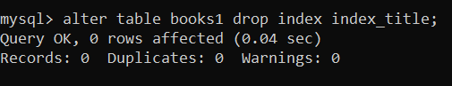

**Views** :



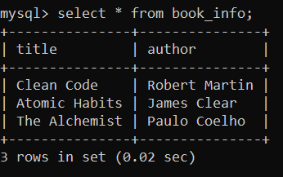

*Updating a view*



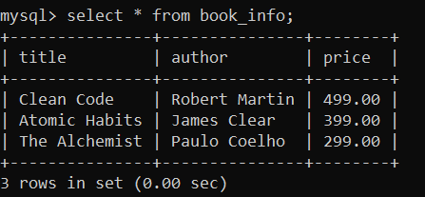

*Dropping view* : to delete a view

Drop view view_name;

